

* How the digestive system works
* That our skeleton protects and supports our organs and enables movement
* That to stay healthy, we need to have a balanced diet and regular exercise
* Medicines can help to help us well

What will I know by the end of this unit of work?

What should I already know?

Topic: Animals including humans

Year: 6

Waterloo Primary School – Science Knowledge Organiser

Report and present findings in oral and written forms such as displays and other presentations

Identify scientific evidence that has been used to support or refute ideas or arguments.

Investigate

Mammals have hearts with four chambers.

The blood that has come from the body is deoxygenated, and the blood that has come from the lungs is oxygenated again. The blood isn’t actually red and blue: we just show it like this on diagrams.

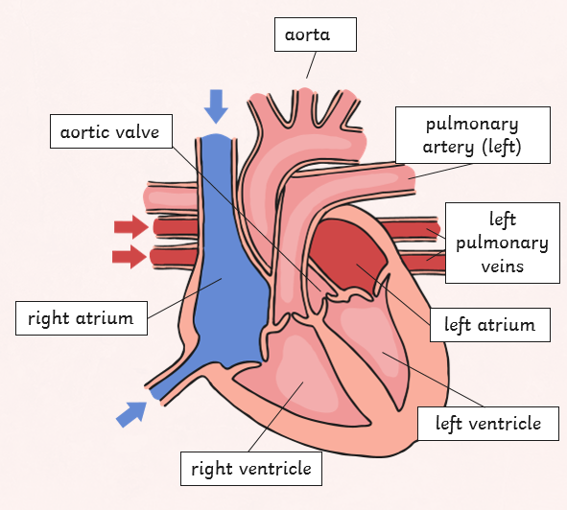

Air breathed in through the mouth or nose travels down the trachea, through the bronchi into one of the lungs. The air travels into the bronchioles and into the air sacs (alveoli).

Arteries – carries oxygenated blood away from the heart

Capillaries – enable exchange of oxygen with body

Veins – carries blood from capillaries back to the heart to be pumped to the lungs to be re-oxygenated.

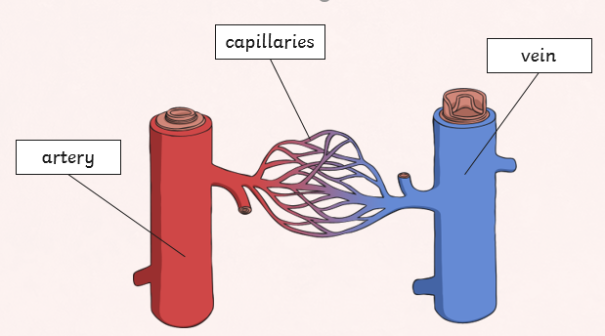

**Arteries** – Muscular-walled tubes that transport blood from the heart to other parts of the body

**Blood** – Red liquid that circulates in arteries and veins, carrying oxygen to and carbon dioxide from tissues of the body

**Blood vessel** – A tubular structure carrying blood through the tissues and organs

**Circulatory system** – The system that circulates blood through the body, including the heart, blood vessels and blood

**Heart** – A hollow muscular organ that pumps the blood through the circulatory system

**Lungs** – Pair of organs situated within the ribcage where oxygen can pass into the blood and carbon dioxide be removed

**Muscles** – A band or bundle of fibrous tissues that have the ability to contract, producing movementin or maintaining positions of parts of the body

**Nutrients** – A substance that provides nourishment essential for the maintenance of life and for growth

**Organs** – Part of an organism that is typically self-contained and has a specific vital function (e.g. the heart and lungs)

**Veins** – Tubes forming part of the blood circulation system of the body, carrying mainly oxygen-depleted blood towards the heart

**Vitamins** – Organic compounds essential for normal growth and nutrition

**Oxygenated blood** – blood that has oxygen from the heart to pump to other parts of he body

**Deoxygenated blood** – blood that has already transferred most of its oxygen

Vocabulary