

Year: 6

Topic: Evolution and Inheritance

Waterloo Primary School – Science Knowledge Organiser

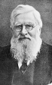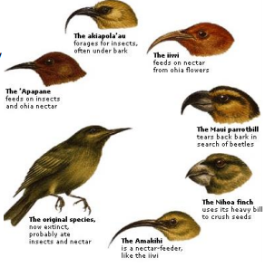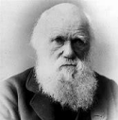

**EVOLUTION BY NATURAL SELECTION**

The theory of evolution by

natural selection was proposed

by Charles Darwin. Organisms

within a species

show a wide range of variation, due to their genes (inherited by their parents) and their environment.

Natural selection occurs through the following steps:

• Individuals within a species show a genetic variation.

• The individuals with the characteristics that means they are better adapted to their environment will survive

• These useful genes are passed onto the next generation. This process occurs over a large number of generations.

**DARWIN’S FINCHES ADAPTATION**

Darwin’s finches are

an excellent example

of the way in which

species’ gene pools

adapt for long term

survival.

Their beaks have

evolved over time to

be best suited to

obtaining food.

**ALFRED WALLACE** – co-published the

theory of evolution by natural

selection with Charles Darwin. He travelled the world and studied

plants and animals. His ideas

were very important in developing

how we think about nature today.

**INHERITANCE** - Are you ever told that you look like your parents? This is because we inherit features and characteristics from them e.g. our natural hair and eye colour, our height or the shape of our face.

**Fossils** – preserved remains of a living thing from the past **Adaptation** – the process of change so that an organism or species can become better suited to their environment

**Environment** – the surroundings or conditions in which a person, animal or plant lives

**Evolution** – the process by which different kinds of living organisms are believed to have developed from earlier forms during the history of the Earth

**Inherit** – to gain a quality, characteristic of predisposition genetically from a parent or ancestor

**Ancestor** – a person from who one is descended

**Offspring** - a person’s/animal’s child or children

**Breeding** – the mating and production of offspring by animals

Vocabulary

**Fossils** are the remains of **prehistoric** life. They are usually formed when a living thing (plant or animal) dies and the body is covered up or buried by **sediment** over tens of thousands of years.

What will I know by the end of this unit of work?

What should I already know?

Investigate

identifying scientific evidence that has been used to support or refute ideas or arguments.