

Plan different types of scientific enquiries to answer questions, including recognising and controlling variables

Measure, using a range of scientific equipment, with increasing accuracy and precision, taking repeat readings when appropriate

Record data and results of increasing complexity using scientific diagrams and labels, classification keys, tables, scatter graphs, bar and line graphs

Use test results to make predictions to set up further comparative and fair tests

Investigate

* That light travels in straight lines.
* That objects can be seen either by the light they give out or the light that reflects off them into the eye.
* That we can see objects because light travels from light sources, bounces off objects and travels to our eyes.
* The shadows have the same shape as the object that casts them because light travels in straight lines.

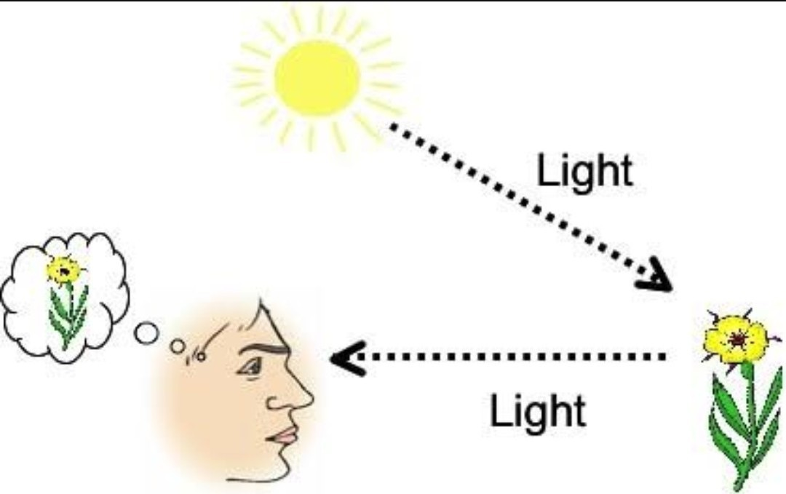

**Travel-** movement of light.

**Absorb-** to take in light.

**Block-** to stop something from passing through.

**Darkness-** the absence of light.

**Direction-** the course along which light travels.

**Light source-** anything which makes its own light.

**Mirror** - reflects objects.

**Torch-** device used to give out light.

**Reflect-** to throw something back without absorbing it.

**Shadow-** a dark area or shape produced by an object coming between rays of light and a surface.

**Translucent**- allows light but not detailed shapes to pass through.

**Transparent**- allows light to shine through so that objects can be seen clearly.

**Opaque-** not able to be seen through.

Vocabulary

* We need light in order to see.
* Materials can be transparent, translucent or opaque.
* That light from the sun can be dangerous.
* That darkness is the absence of light.

What should I already know?

What will I know by the end of this unit of work?

Strand:

Waterloo Primary School – Science Knowledge Organiser

Year: 6

Topic: Light