

Year: 4 Strand: Biology

Topic: Animals Including Humans

Waterloo Primary School – Science Knowledge Organiser

The simple function and basic parts of the digestive system. How to explain the digestive system to a friend.

The different types of human teeth and their functions.

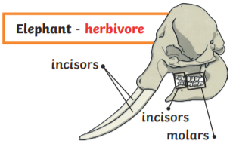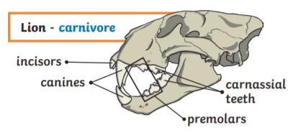

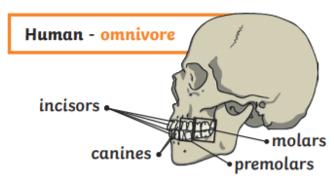

How to describe and explain food chains using scientific vocabulary. Construct simple food chains.

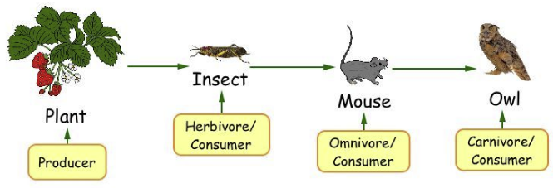

Investigate

* Recording findings using simple scientific language, drawings, labelled diagrams and keys

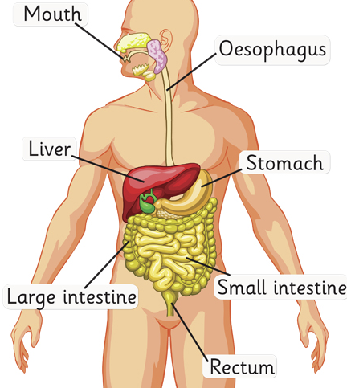

* Producer – a living thing that makes its own food
* Consumer – a living thing that eats another living thing
* Perdator – hunts and kills its food
* Prey – is hunted/killed for food
* Carnivore – eats meat
* Herbivore – eats plants
* Omnivore – eats both

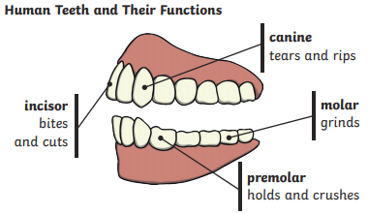

Vocabulary

* Animals that are carnivores, herbivores and omnivores
* That animals, including humans, have offspring which grow into adults
* The basic needs of animals, including humans, for survival (water, food and air)
* The importance for humans of exercise, eating the right amounts of different types of food, and hygiene.

What will I know by the end of this unit of work?

What should I already know?