

|  |  |
| --- | --- |
| **Absorb** | soak up or take in |
| **Fossils** | remains or impression of a prehistoric plant or animal embedded in rock and preserved in petrified form |
| **Nutrients**  **Organic** | substances that help plants and animals to grow  **matter derived from organisms, especially decayed matter in soil** |
| **Palaeontology** | the study of **fossils** as a guide to the history of life on Earth |
| **Permeable** | if a substance is permeable, something such as water or gas can pass through it or soak into it |
| **Properties** | the qualities or features that belong to something and make it recognisable |
| **Rock** | a solid mass made up of **minerals**. Rock forms much of the earth's outer layer, including cliffs and mountains |
| **soil** | the substance on the **surface** of the earth in which plants grow |

Vocabulary

* **Soil** contains **nutrients**
* That materials can be absorbent and that plant roots absorb nutrients and water from the soil
* That some materials are used for certain purposes because of their **properties**

Investigate

* Explore the types of **rocks** you can find in the local environment.
* Explain why **rocks** are used for different purposes, based on their **properties.**
* Research the different living things whose **fossils** are found.
* Explore the different kinds of **soils.**
* Investigate what happens when **rocks** are rubbed together.
* Investigate what happens to **rocks** when they are in water.

There are three types of **rocks** that are formed **naturally.**

• **Igneous:**

• When **molten magma** cools, **igneous rocks** are formed.

• This either cools and forms **rocks** under the earth’s **surface**, or flows out of erupting **volcanoes** as lava and may mix with other **minerals**.

• Examples include granite and bas-alt.

• **Sedimentary:**

• Sometimes, little pieces of rocks that have been **weathered** can be found at the bottom of lakes, seas and rivers This is called **sediment.**

• Over millions of years, layers of this **sediment** builds up forming **sedimentary rocks.**

• Examples include limestone and chalk.

• **Sedimentary rocks** are **porous** and can easily be worn down.

**• Metamorphic:**

• When some **igneous** and **sedimentary** rocks are heated and squeezed (**pressured)**, they form **metamorphic rocks.**

• Examples include slate and marble.

• **Metamorphic rocks** are strong.

**Chalk, clay, granite, marble, sandstone, marble and slate** are all types of rock.

**Fossils** are the remains of **prehistoric** life.

• They are usually formed when a living thing (plant or animal) dies and the body is covered up or buried by **sediment** over tens of thousands of years.

**Soil** is made from pieces of rock, **minerals, decaying** plants and water.

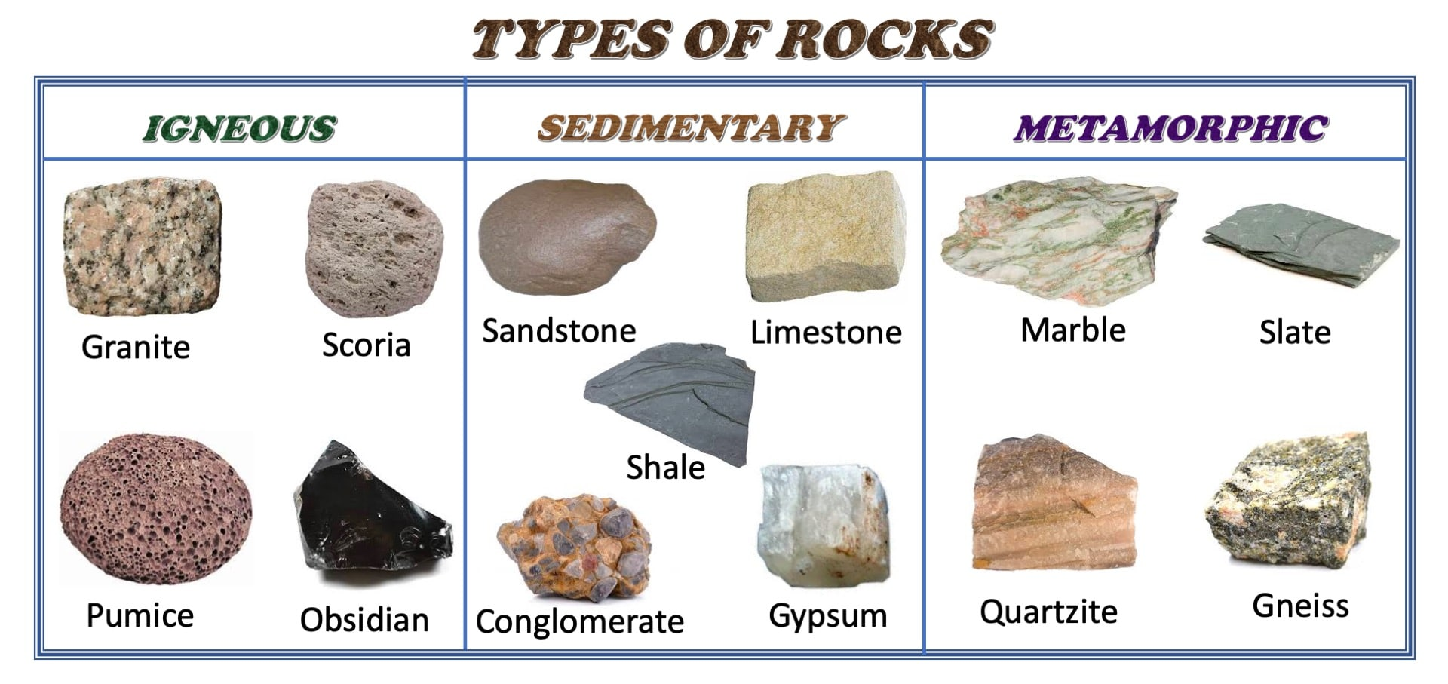

What will I know by the end of this unit of work?

Waterloo Primary School – Science Knowledge Organiser

Strand: Chemistry

What should I already know?

Year: 3

Topic: Rocks