Vocabulary

* Animals, including humans, have offspring which grow into adults.

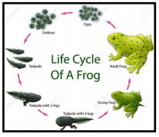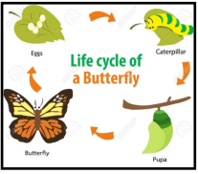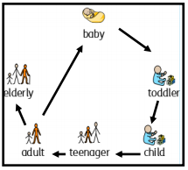

* Animals, including humans, have offspring which grow into adults
* All animals, including humans have basic needs
* To keep physically healthy, we need a healthy diet and regular exercise. We have to keep ourselves clean
* It is also important to look after our mental health
* When I exercise I feel different

I will be able to:

* Ask simple questions and recognise that they can be answered in different ways
* Make careful observations and use them to suggest answers
* Gather, record and present information

What will I know by the end of this unit of work?

Year: 2

* There are five types of vertebrates (mammals, fish, reptiles, amphibians, birds).
* Vertebrates are animals that have a backbone.
* Some animals give birth to live young but others lay eggs.

What should I already know?

Topic: Animals including humans

Waterloo Primary School – Science Knowledge Organiser

Life Cycle – changes that happen from birth until death

Disease – illness

Personal hygiene – keeping yourself clean

Medicines – treatments for illness or pain

Muscle- tissue in the body that enables movement

Survive – continue to exist

Skeleton – framework of bones in your body

Pictogram – simple images that represent something

Offspring – an animal’s young

Bar chart – a chart which uses bars to show and compare amounts

Backbone – column of small bones in your back