

* Absorbent – material that soaks up liquid easily.
* Dull – a colour or light that is not bright.
* Man-made – things created by people.
* Natural – things that exist in nature and are not made by people.
* Process – a series of actions used to produce something or reach a goal.
* Properties – the qualities or features that belong to something and make it recognizable.
* Purpose – the reason for which it is made or done.
* Recyclable – waste or materials which can be processed and used again.
* Transparent – if an object is transparent, you can see through it.
* Suitable – something that is suitable for a particular purpose or occasion due to its properties.

Vocabulary

* Objects are things that you can touch or see.
* Objects are made from different materials.
* Some words to describe these materials e.g. soft, smooth, shiny, rough etc.
* Consider why some properties of materials make them suitable or unsuitable for different uses.
* Investigate how some objects can be changed by squashing, bending, twisting and stretching.
* Investigate if some materials can be used to make more than one thing.

Investigate

* That materials are used for different purposes based on their properties.

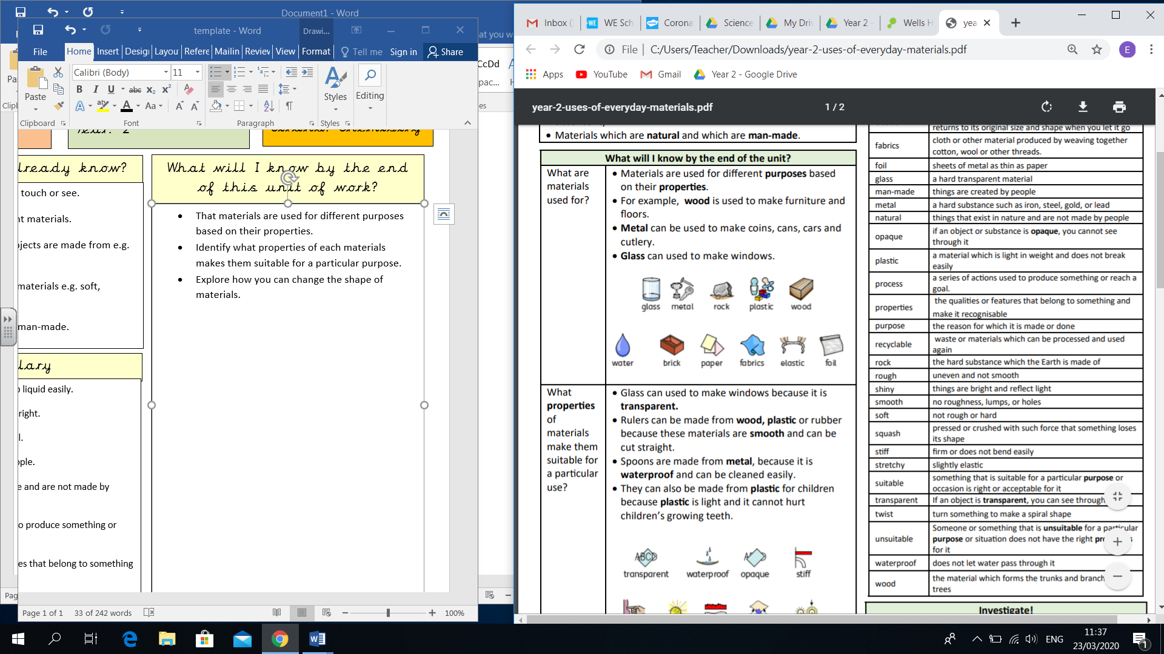

* That materials have properties which make them suitable or unsuitable for a particular purpose.
* Some materials are waterproof and some are absorbent
* We can change the shape of some materials in different ways

What should I already know?

What will I know by the end of this unit of work?

Waterloo Primary School – Science Knowledge Organiser

Year: 2

Topic: Materials