
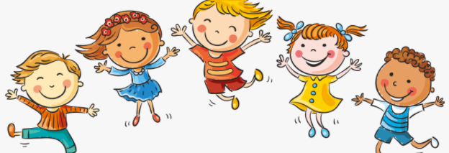
I know that life cycles exist in nature
I know that aging is a natural process including old-age
I know that some changes are out of our control
I know how my body has changed from when I was a baby and that it will change more as I get older
I know some physical differences between male and female bodies
I know the correct names for private body parts and when it is appropriate to talk about them
I know that private body parts are special and that no one has the right to hurt them
I know there are different types of touch and that some are acceptable and some are unacceptable
I Know who I can talk to if my body isn’t being respected

Change
Grow
Cuddle, Hug, Squeeze,
Control
Life cycle
Respect
Appearance
Physical
Baby, Toddler, Child, Teenager, Adult
Independent
Timeline
Freedom
Male/Female
Private body parts: vagina, penis, testicles, vulva, anus
Acceptable/Unacceptable
Comfortable/Uncomfortable
Vocabulary
- Physical differences between boys and girls
- Which body parts are private and the correct names for them

Topic: Changing Me
Year:2
Summer 2
What should I already know?
What will I know by the end of this unit of work?
Waterloo Primary School – PSHE Knowledge Organiser

