
- I know what family is and that different people in families have different jobs (responsibilities)
- I know when friendships are working well and I know some ways to be a good friend
Family
Belong
Qualities
Caring/Sharing/Kind
Greeting
Touch/Feel
Texture
Like/Dislike
Community
Confidence
Praise
Skills
Self-belief
Appreciate
Vocabulary
I know that all of our families are different
I Know that there are lots of different types of families
I Know that families can give feelings of belonging, love and care
Know some qualities that make a good friend
I know that physical contact can be used as a greeting
I know about the different people my school community and how they help us
I know who to ask for help in the school community
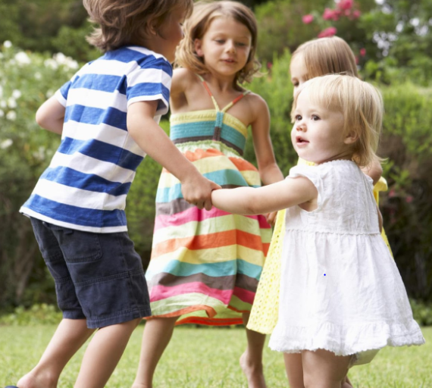
I know that violence at home, in school or in the community is unacceptable
Topic: Relationships
Year:1
Summer 1
What should I already know?
What will I know by the end of this unit of work?
Waterloo Primary School – PSHE Knowledge Organiser

