
- I know how to say no to strangers
- I know what to do if I get lost
- When and how to wash my hands
- I know some names of body parts
- I know that sleep/exercise/healthy foods are good for me

Vocabulary
Healthy/Unhealthy
Balanced
Exercise
Sleep
Choices
Body parts
Toiletry items (toothbrush, shampoo, soap)
Hygienic
Safe Medicines
Trust
Green Cross Code
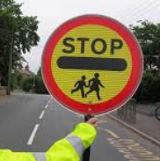
Germs
Illness/disease
I know some ways to keep healthy
I know how to make healthy lifestyle choices
I know how to keep myself clean and healthy
I know that germs can cause disease / illness
I know that household products, including medicines, can be harmful if not used properly
I know that medicines can help me if I feel poorly
I know how to keep safe when it is sunny
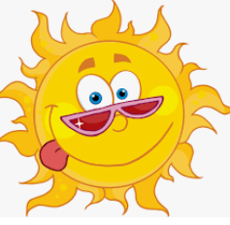
I know how to keep safe when crossing the road
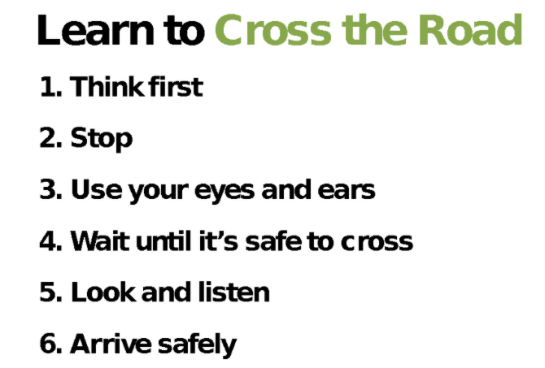
I know different people who can keep me safe

Topic: Healthy Me
Year:1
Spring 2
What should I already know?
What will I know by the end of this unit of work?
Waterloo Primary School – PSHE Knowledge Organiser

