
- I know what a challenge is
- I know that it is important to keep trying
- I know what a goal is
- I can talk about a job I might like to do in the future

Vocabulary
Proud
Success
Achievement
Goal
Treasure
Goal
Stepping-stones
Process
Team work
Celebrate
Challenge
Obstacle
Overcome
Achieve
Dreams
Goals
What should I already know?
I know how to set myself simple goals
I know how to achieve a goal
I know how to work well with a partner
I can spot obstacles which may make achieving my goal difficult
I know who and what can help me to overcome obstacles
I know I can overcome some obstacles and how this feels
I know how I learn best
I know I can celebrate my achievements
I can store things that I am proud of in my internal treasure chest.
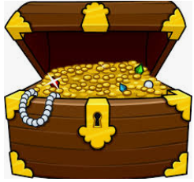
Topic: Dreams and Goals
Year:1
Spring 1
What will I know by the end of this unit of work?
Waterloo Primary School – PSHE Knowledge Organiser

