

Similarity

Same as

Different from

Difference

Bullying

Bullying behaviour

Deliberate/intended/on purpose

Unique

Unfair

Included

Bully

Bullied

Celebrations

Special

Negative

Vocabulary

* I know how it feels to be proud
* We are all different
* We are all good at different things
* Families can be different
* I can make friends
* I can stand up for myself (appropriately)

We all have differences and similarities

Bullying is repeated negative behaviour that is intended to make others feel upset, uncomfortable or unsafe.

I can tell my friends, grown-ups at home, grown-ups in school if I am bullied or if I witness bullying

I can make friendships in different ways

People are unique and it is okay to be different

In some ways, I am the same as my friends and in some ways I am different

I am special!

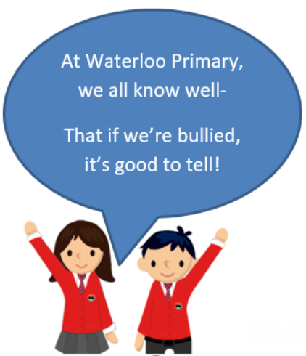

Topic: Celebrating Difference

Year:1

Autumn 2

What should I already know?

What will I know by the end of this unit of work?

Waterloo Primary School – PSHE Knowledge Organiser