
Safe
Special
Calm
Belonging
Special
Rights
Responsibilities
PSHE Code of Conduct
Rewards
Proud
Consequence
Upset
Disappointed
Vocabulary
- Some things that make me special
- We are all different and special
- What it can look/sound like when people are sad/happy
- Hands can be used kindly and unkindly

- We all have rights and responsibilities in our class
- My views are important
- My choices have consequences
- I am special
- I am safe in my class
- Some behaviours help to make my class a safe place
- I can feel proud
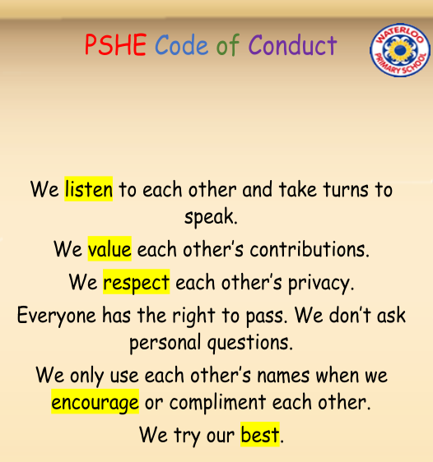
Topic: Being Me in My World
Year:1
Autumn 1
What should I already know?
What will I know by the end of this unit of work?
Waterloo Primary School – PSHE Knowledge Organiser

