

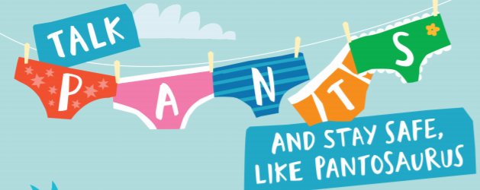

I Know that animals including humans have a life cycle

I Know that changes happen when we grow up

Know that we all grow at different rates and that is normal

I Know who I can talk to if my body isn’t being respected or if I am worried

I know that what is in my pants, my chest and my mouth are private

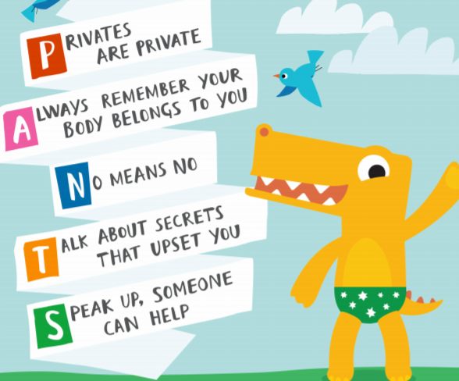

Changes

Life cycles

Baby

Adult/Adulthood

Grown-up

Mature

Male/Female

Anxious

Worried

Excited

Coping

Private body parts

Vocabulary

I know the names of some body parts

I know we grow from babies to adults

I know who I can talk to if I am worried

Topic: Changing Me

Year:2

Summer 2

What should I already know?

What will I know by the end of this unit of work?

Waterloo Primary School – PSHE Knowledge Organiser