
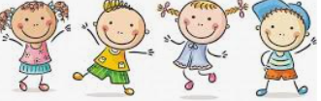
I know that all families are different
I know that families function well when there is trust, respect, care, love and co-operation
I know that there are lots of forms of physical contact
I Know how to say stop if someone is hurting me or making me feel uncomfortable
I know some reasons why friends have conflicts
I know that friendships have ups and downs and sometimes change with time
I know how to use the ‘Mending Friendships’ or ‘Solve-it-together’ problem-solving methods
I know there are good secrets and worry secrets and why it is important to share worry secrets
I know how to give and receive compliments
Similarities/Differences
Relationship
Co-operate
Physical contact
Communication
Acceptable/unacceptable
Conflict
Point of view
Positive problem solving
Good secret/Worry secret
Trustworthy
Honesty
Reliability
Compliments
Appreciate
Vocabulary
- I know which people are special to me and how this makes me feel.
- I know some qualities that make a someone a good friend
Topic: Relationships
Year:2
Summer 1
What should I already know?
What will I know by the end of this unit of work?
Waterloo Primary School – PSHE Knowledge Organiser

