
I know what my body needs to stay healthy
I know what can make me feel tense and what can help me to feel relaxed
I know that it is important to use medicines safely
I know how to make some healthy snacks
I know which foods give my body energy
I understand how to keep safe when travelling in a car (wearing a seat belt/being calm and quiet)
I know that rail tracks can be dangerous
I know how to keep safe when near water
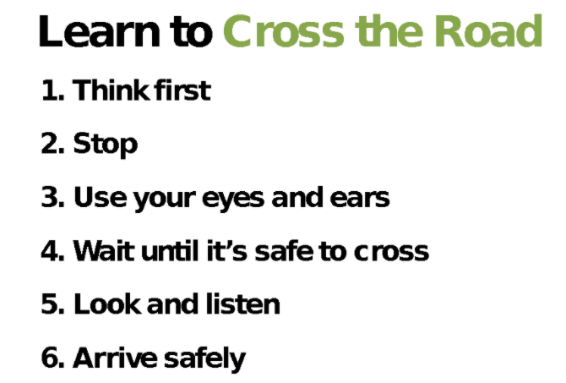

Healthy choices
Lifestyle
Motivation
Relax/Relaxation
Tense
Calm
Dangerous/Safe
Medicines
Balanced diet
Portion
Proportion
Energy
Fuel
Nutrients/Nutritious
Safety Lines:
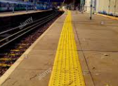
Vocabulary
- My body is special and I need to take care of it
- How to cross a road safely
- How to stay safe in the sun
Topic: Healthy Me
Year:2
Spring 2
What should I already know?
What will I know by the end of this unit of work?
Waterloo Primary School – PSHE Knowledge Organiser

