
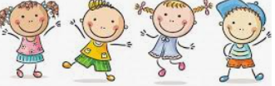
know that different family members carry out different roles or have different responsibilities within the family
Know that gender stereotypes can be unfair
Know some of the skills of friendship (taking turns, being a good listener)
Know some strategies for keeping myself safe online
Know how some of the actions and work of people around the world help and influence my life
Know that I and all children have rights (UNCRC)
Know the lives of children around the world can be different from mine
Unisex
Male/Female
Stereotype
Career
Respect
Social media/Online
Risky
Private messaging
Direct messaging
Global
Fair trade
Equality/Inequality
Climate
Exploitation
Rights/Needs/Wants
Justice
United Nations
Deprivation/hardships
Vocabulary
Different things that can cause conflicts with friends
Family make-ups can be different
Topic: Relationships
Year:3
Summer 1
What should I already know?
What will I know by the end of this unit of work?
Waterloo Primary School – PSHE Knowledge Organiser

