

Oxygen

Energy

Calories / kilojoules

Heartbeat

Lungs

Labels

Sugar/Fat/Saturated fat

Drugs

Attitude

Anxious

Strategy

Advice

Harmful

Risk

Complex

Appreciate

Vocabulary

* How to stay safe when travelling in a car
* How to cross a road
* Rail tracks can be dangerous
* How to stay safe in the sun
* The importance of a healthy diet

Know how exercise affects my body

Know why my heart and lungs are such important organs

Know that the amount of calories, fat and sugar that I put into my body will affect my health

Know that there are different types of drugs

Know that there are things, places and people that can be dangerous

Know a range of strategies to keep myself safe

Know when something feels safe or unsafe

Know that my body is complex and need taking care of

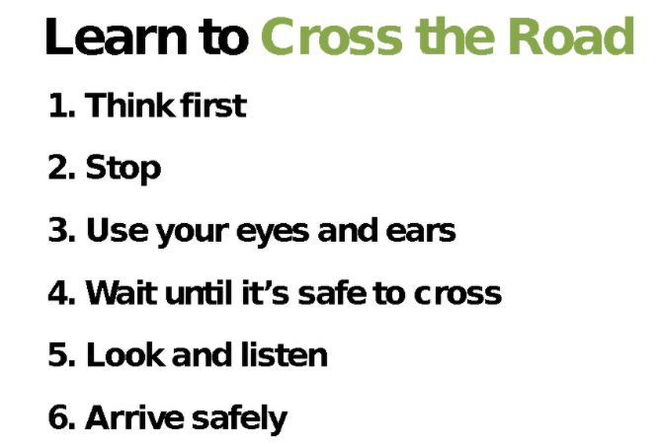

Topic: Healthy Me

Year:3

Spring 2

What should I already know?

What will I know by the end of this unit of work?

Waterloo Primary School – PSHE Knowledge Organiser