
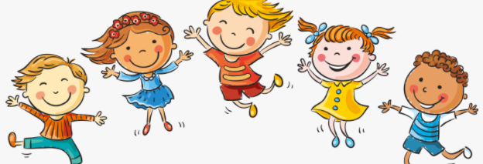
Know that in animals and humans lots of changes happen between conception and growing up
Know that in humans a mother carries the baby in her uterus (womb) and this is where it develops
Know that babies need love and care from their parents/carers
Know some of the changes that happen between being a baby and a child
Know that the male and female body needs to change at puberty so their bodies can make babies when they are adults
Know some of the outside body changes that happen during puberty
Know some of the changes on the inside that happen during puberty (including menstruation)
Uterus
Womb
Nutrients
Survive
Love/Affection/Care
Puberty
Male/Female
Testicles
Sperm
Penis
Ovaries
Vagina

Vocabulary
The names of body parts that are different for boys and girls
Topic: Changing Me
Year:3
Summer 2
What should I already know?
What will I know by the end of this unit of work?
Waterloo Primary School – PSHE Knowledge Organiser

