
Know why families are important
Know that everybody’s family is different
Know that sometimes family members don’t get along and some possible reasons for this
Know that conflict is a normal part of relationships
Know what it means to be a witness to bullying and that a witness can make the situation worse
Know that some words are used in hurtful ways and that this can have consequences
Know how to use the ‘Solve it together’ technique to calm and resolve conflicts with friends and family
Know how to give and receive compliments
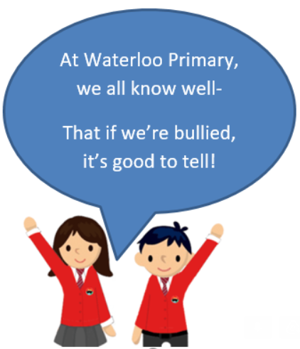

Loving
Caring
Safe
Connected
Difference
Conflict
Solve It Together
Solutions
Resolve
Witness
Bystander
Gay
Consequences
Compliment
Unique
Vocabulary
- That my friend and I have similarities and differences
- Know what bullying is and how to report it

Topic: Celebrating Difference
Year:3
Autumn 2
What should I already know?
What will I know by the end of this unit of work?
Waterloo Primary School – PSHE Knowledge Organiser

