
- That may behaviour can impact on other people in my class
- That choices can have good and bad consequences
Know that I can set personal goals and challenges
Know why rules are needed and how these relate to choices and consequences
Know that actions can affect others’ feelings
Know that others may hold different views
Know our school code of conduct
Know I have personal strengths
Know that I and others experience feelings of happiness, sadness, worry and fear
Know how to make others feel valued
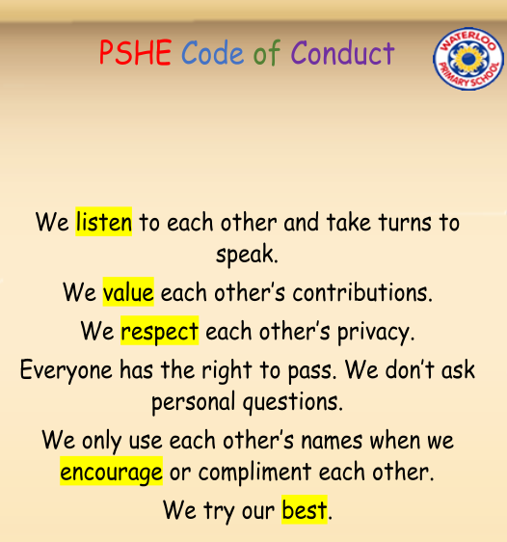
Welcome
Valued
Achievements
Personal Goal
Acknowledge
Affirm
Emotions
Nightmare
Worries
Solutions
Support
Rights/Responsibilities
Rewards/Consequences
Fairness
Choices
Co-Operation
Group Dynamics
Team work
Vocabulary
Topic: Being Me in My World
Year:3
Autumn 1
What should I already know?
What will I know by the end of this unit of work?
Waterloo Primary School – PSHE Knowledge Organiser

