
I know there are stereotypes about boys and girls
I know that we don’t have to conform to these gender stereotypes
I know it’s good to be myself
I know that sometimes people get bullied because of difference
I know the difference between right and wrong and the role that choice has to play in this
I know that friends can be different and still be friends
I know where to get help if I am being bullied or I witness bullying
I know the difference between a one-off incident and bullying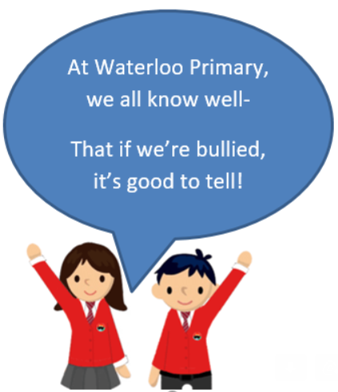
Gender
Boys/Girls
Similarities/Differences Assumptions
Shield
Stereotypes
Purpose
Lonely
Stand up for
Male/Female
Diversity
Fairness
Kindness
Unique
Value
Incident
Vocabulary
I know we are all different
I know how to report bullying
Topic: Celebrating Difference
Year:2
Autumn 2
What should I already know?
What will I know by the end of this unit of work?
Waterloo Primary School – PSHE Knowledge Organiser

