
I know why my class is a safe place
I know we all have rights and responsibilities

I know my hopes and fears for the year ahead
I know the rights and responsibilities myself and my class members have
I know that it is important to listen to other people
I know that my views are valuable
I know about rewards and consequences
I know that my actions can impact on others
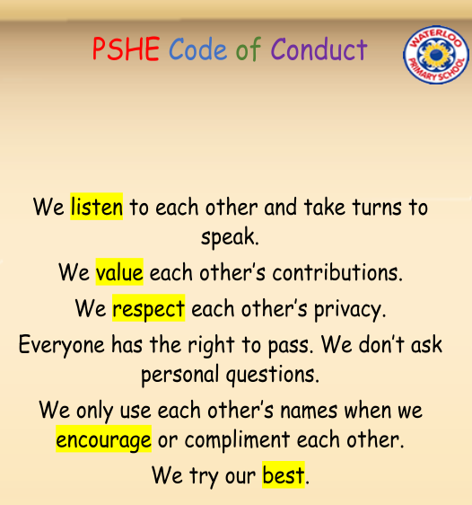
Worries
Hopes
Fears
Belonging
Rights/Responsibilities
Actions
Praise/Reward
Consequence
Positive/Negative
Choices
Co-Operate
Problem-Solving
Vocabulary
Topic: Being Me in My World
Year:2
Autumn 1
What should I already know?
What will I know by the end of this unit of work?
Waterloo Primary School – PSHE Knowledge Organiser

