
Immunisation/Vaccination
Prevention
Prescribed/Over-the-counter
Restricted/Unrestricted
Legal highs
Exploited
Vulnerable
Crime/Criminal
County lines
Reputation
Anti-social behaviour
Mental illness
Managing stress
Terrorism
Extremism
Radicalisation

Vocabulary
I know that people can have healthy and unhealthy relationships with food

- I Know how to take responsibility for my own health and wellbeing
- I Know about different types of drugs and their uses
- I know that some people (including children) can be exploited and made to do things that are against the law
- I know some ways to keep myself safe from exploitation
- I Know why some people join gangs and the risk that this can involve
- I know that stress can be triggered by a range of things
- I know how to travel safely

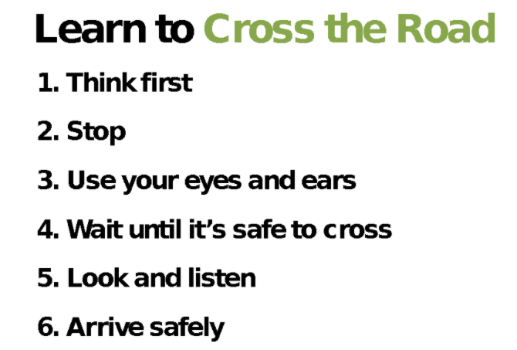

Topic: Healthy Me
Year:6
Spring 2
What should I already know?
What will I know by the end of this unit of work?
Waterloo Primary School – PSHE Knowledge Organiser

