
Perception
Self-esteem
Affirmation
mental health
midwife/labour
Hygiene
Age appropriateness
Legal/Laws
Attraction
Sexting
Transition
Body parts: uterus/womb, oestrogen, fallopian tube, cervix, breasts, vagina, vulva, hips, penis, testicles, Adam’s apple, scrotum, genitals, foreskin, ovaries
Puberty/changes: hair, broader, wider, sperm, semen, erection, ejaculation, urethra, wet dream, growth spurt, larynx, hormones, scrotum, testosterone, ovum, periods, menstruation
FGM: Female Genital Mutilation

Vocabulary
Some physical and emotional changes that occur during puberty
When it is appropriate to take about private body parts, puberty and sex
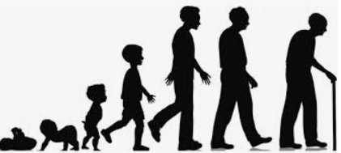
Know how girls’ and boys’ bodies change during puberty
Know the importance of looking after myself physically and emotionally
Know how a baby develops from conception through the nine months of pregnancy and how it is born
Know how being physically attracted to someone changes the nature of the relationship
Know the importance of self-esteem and what I can do to develop it
Know what I are looking forward to and what I am worried about when thinking about transition to secondary school
Topic: Changing Me
Year:6
Summer 2
What should I already know?
What will I know by the end of this unit of work?
Waterloo Primary School – PSHE Knowledge Organiser

