
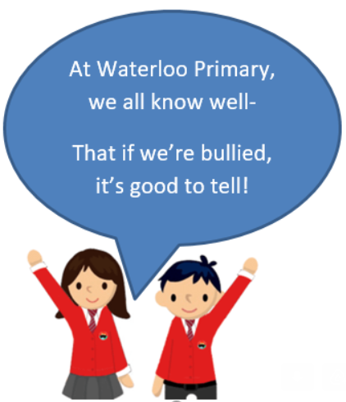
- Know that there are different perceptions of ‘being normal’ and where these might come from
- Know that being different could affect someone’s life
- Know that power can play a part in a bullying or conflict situation
- Know that people can hold power over others individually or in a group
- Know why some people choose to bully others
- Know that people with disabilities can lead amazing lives
- Know that difference can be a source of celebration as well as conflict

Ability
Disability
Visual impairment
Blind
Empathy
Perception
Medication
Diversity
Transgender
Gender Diversity
Harassment
Para-Olympian
Accolade
Perseverance
Stamina
Vocabulary
- I know that difference can be the cause of bullying
- I know what indirect and direct bullying are

Topic: Celebrating Difference
Year:6
Autumn 2
What should I already know?
What will I know by the end of this unit of work?
Waterloo Primary School – PSHE Knowledge Organiser

