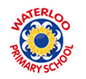
I know that we have rules, rights and responsibilities to make our community fairer

- Know how to set goals for the year ahead
- Know about children’s universal rights (United Nations Convention on the Rights of the Child)
- Know that my personal choices can affect others locally and globally
- Know how democracy and having a voice benefits our school community
- Understand how to contribute towards the democratic process

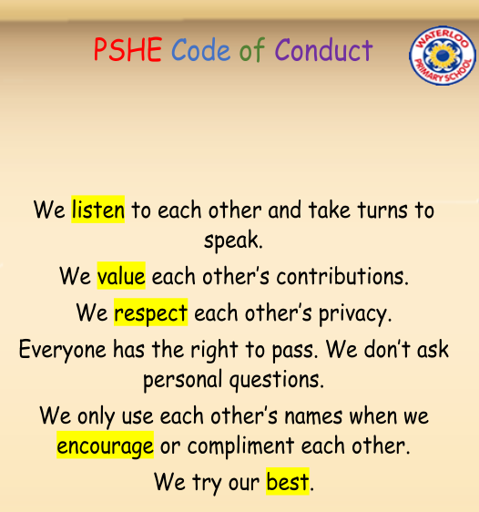
Challenge
Goal
Attitude
Actions
Rights and Responsibilities
United Nations Convention on The Rights of the Child
Citizen
Choices
Consequences
Views
Opinion
Collaboration
Collective Decision
Democracy
Vocabulary
Topic: Being Me in My World
Year:6
Autumn 1
What should I already know?
What will I know by the end of this unit of work?
Waterloo Primary School – PSHE Knowledge Organiser

