
- Know that a personality is made up of many different characteristics, qualities and attributes
- Know that belonging to an online community can have positive and negative consequences
- There are rights and responsibilities in an online community or social network
- Know that there are rights and responsibilities when playing a game online
- Too much screen time isn’t healthy
- Know how to stay safe when using technology to communicate with friends
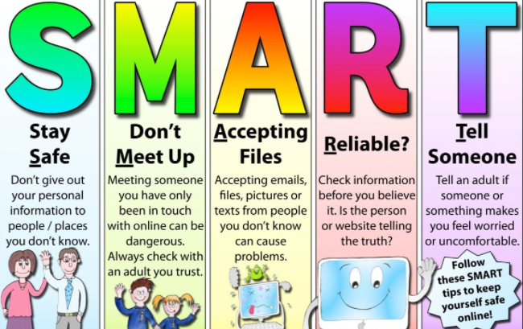
Personal attributes/characteristics
Negative self-talk
Social media
Social network
Gaming
Grooming
Troll
Gambling/ Betting
Screen time
Physical health/mental health
Peer pressure
Influences
SMART rules
Vocabulary
Know there are different ways to help deal with loss

Topic: Relationships
Year:5
Summer 1
What should I already know?
What will I know by the end of this unit of work?
Waterloo Primary School – PSHE Knowledge Organiser

