
Body-image
Affirmation
Body parts: uterus/womb, oestrogen, fallopian tube, cervix, breasts, vagina, vulva, hips, penis, testicles, Adam’s apple, scrotum, genitals, foreskin, ovaries
Puberty/changes: hair, broader, wider, sperm, semen, erection, ejaculation, urethra, wet dream, growth spurt, larynx, hormones, scrotum, testosterone, ovum, periods, menstruation
Circumcised/Uncircumcised
Fertilised/Unfertilised
Conception: sexual intercourse
Embryo
Umbilical cord
IVF
Foetus
Contraception
Pregnancy
Hygiene
Vocabulary
Some of the ways our bodies change as we grow which prepare us for having babies
Who I can talk to if my body isn’t being respected by someone
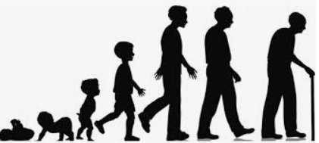
Know what perception means and that perceptions can be right or wrong
Know how girls’ and boys’ bodies change during puberty
Know the importance of looking after myself physically and emotionally
Know that sexual intercourse can lead to conception
Know that some people need help to conceive and might use IVF
Know that becoming a teenager involves various changes and also brings growing responsibility

Topic: Changing Me
Year:5
Summer 2
What should I already know?
What will I know by the end of this unit of work?
Waterloo Primary School – PSHE Knowledge Organiser

