

* Know what culture means
* Know that differences in culture can sometimes be a source of conflict
* Know what racism is and why it is unacceptable
* Know that rumour spreading is a form of bullying on and offline
* Know external forms of support in regard to bullying e.g. Childline
* Know that bullying can be direct and indirect
* Know how my life is different from the lives of children in the developing world

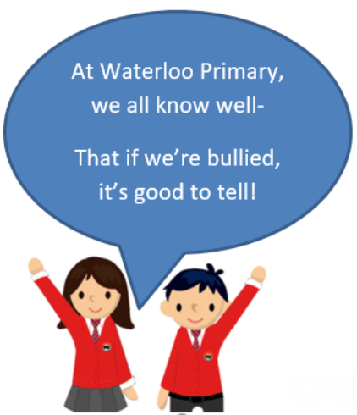

Culture

Conflict

Race/Racism/Racist

Discrimination

Rumour

Homophobic

Cyber bullying

Indirect/Direct bullying

Developing World

Vocabulary

* First impressions aren’t always right.
* What to do if I witness bullying of any kind

Topic: Celebrating Difference

Year:5

Autumn 2

What should I already know?

What will I know by the end of this unit of work?

Waterloo Primary School – PSHE Knowledge Organiser