
- The importance of listening within our community
- What it means to be democratic
- Know how to face new challenges positively
- Know how to set personal goals
- The rights and responsibilities associated with being a citizen in the wider community and my country
- Know how an individual’s behaviour can affect a group
- How democracy and having a voice benefits the school community
- The age of criminal responsibility is 10

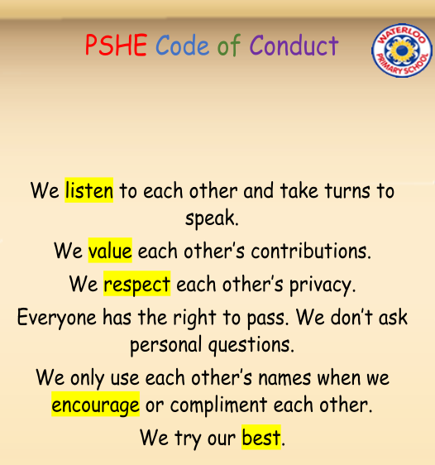
Ghana/West Africa
Cocoa Plantation
Cocoa Pods
Machete
Rights/Wants/Needs
Community
Maslow
Empathy
Comparison
Opportunities
Responsibilities
Cooperation
Collaboration
Legal/Illegal
Participation
Motivation
Democracy
Vocabulary
Topic: Being Me in My World
Year:5
Autumn 1
What should I already know?
What will I know by the end of this unit of work?
Waterloo Primary School – PSHE Knowledge Organiser

