
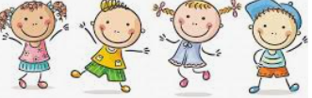
Know some reasons why people feel jealousy
Know that jealousy can be damaging to relationships
Know that we all experience feelings of loss
Know that loss is difficult to cope with and that some negative feelings are normal
Know that memories can support us when we lose a special person or animal
Know that change is a natural part of relationships/ friendship
Know that sometimes it is better for a friendship/ relationship to end if it is causing negative feelings or is unsafe
Jealousy
Loss
Shock/Disbelief
Numb
Denial
Guilt
Despair
Sentimental
Memorial
Acceptance
Relief
Negotiate
Compromise
Loyal
Empathy
Betrayal
Amicable
Appreciation
Vocabulary
That some of the things we buy affect the livelihoods of others
Topic: Relationships
Year:4
Summer 1
What should I already know?
What will I know by the end of this unit of work?
Waterloo Primary School – PSHE Knowledge Organiser

