
Value
Leader/Follower
Assertive
Agree/Disagree
Smoking
Pressure
Peers
Guilt
Advice
Alcohol
Liver
Disease
Anxiety
Believe
Opinion
Right/Wrong
Vocabulary
- Know who to go to if I feel unsafe
- Know I can make healthy life choices
- Know that different drugs can be helpful or harmful
Know which friends I value and why
Know that there are leaders and followers in groups
Know the facts about smoking and its effects on health
Know some of the reasons some people start to smoke
Know the facts about alcohol and its effects on health, particularly the liver
Know some of the reasons some people drink alcohol
Know ways to resist when people are putting pressure on me
Know what I think is right and wrong
I understand the importance of brushing my teeth thoroughly
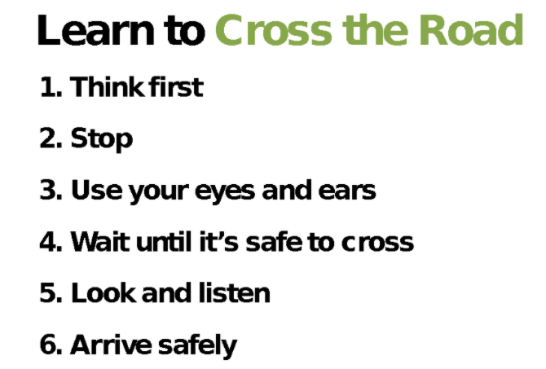
Topic: Healthy Me
Year:4
Spring 2
What should I already know?
What will I know by the end of this unit of work?
Waterloo Primary School – PSHE Knowledge Organiser

