
Personal
Sperm
Egg
Penis
Testicles
Vagina
Vulva
Womb/Uterus
Ovaries
Fertilise
Puberty
Periods/Menstruation
Vocabulary
Some of the ways our bodies change as we grow which prepare us for having babies
Who I can talk to if my body isn’t being respected by someone
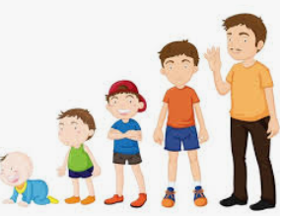
Know the names of the different internal and external body parts that are needed to make a baby
Know how the female and male body change during puberty
Know that personal hygiene is important during puberty and as an adult
Know that change is a normal part of life and that some cannot be controlled and have to be accepted
Know that change can bring about a range of different emotions
Topic: Changing Me
Year:4
Summer 2
What should I already know?
What will I know by the end of this unit of work?
Waterloo Primary School – PSHE Knowledge Organiser

