

* That I can make responsible choices in school
* That there I are people I can to for help
* That rules are important

Know how individual attitudes and actions make a difference to my class

Know about the different roles in my school community

Know my place in our school community

Know what democracy is (School Council)

Know that my actions affect myself and others

Know how groups work together to reach a consensus

Know that having a voice and democracy benefits the school community

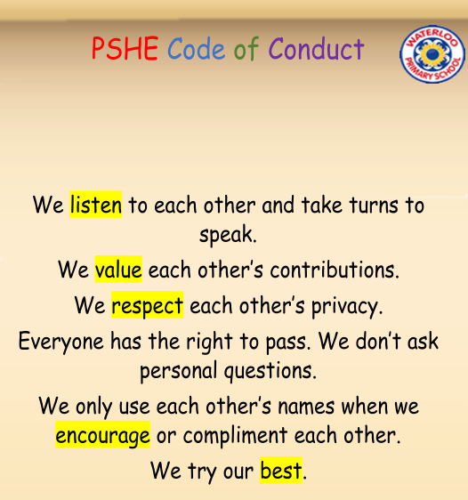

Included/Excluded

Welcome

Valued

Role

Job Description

School Community

Responsibility

Rights

Democracy

Democratic

Reward

Consequence

Decisions

Voting

Authority

Contribution

Observer

UN Convention on Rights of Child (UNCRC)

Vocabulary

Topic: Being Me in My World

Year:4

Autumn 1

What should I already know?

What will I know by the end of this unit of work?

Waterloo Primary School – PSHE Knowledge Organiser