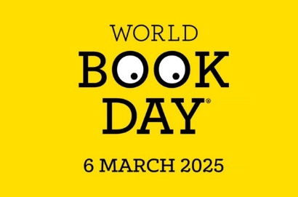

**Potato Challenge World Book Day Competition**

To celebrate World Book Day on Thursday 6th March we are running a competition to create a book character from a potato. Use a potato and be as creative as you like to turn it into a book character of your choice. You may use any materials you like. Use whatever you have at home.

Have a look at the examples to give you some ideas. Do you recognise any of the characters?

Remember your potato needs to be a character from a book.

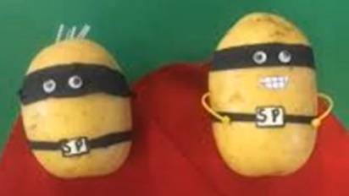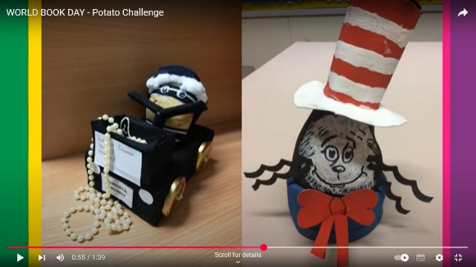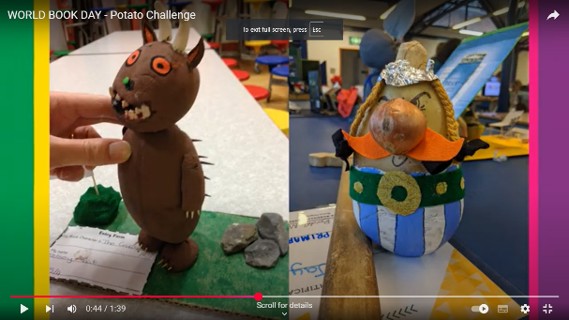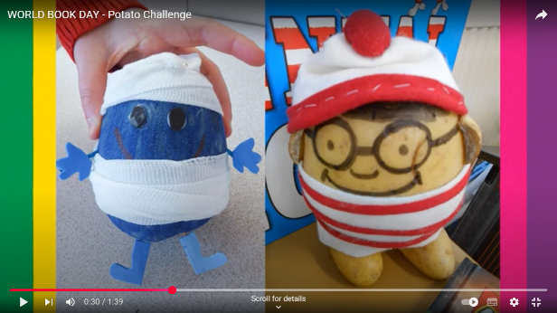

Entries will be judged on effort and creativity and winners will be chosen from each year group and announced in our assembly on Monday 10th March. Please bring your potato characters into school on World Book Day so we can display all entries in the hall and guess what character and book your potato is from.

Good luck!

Miss Au