Poetry Books/ Writing Kit Available From Ian Bland

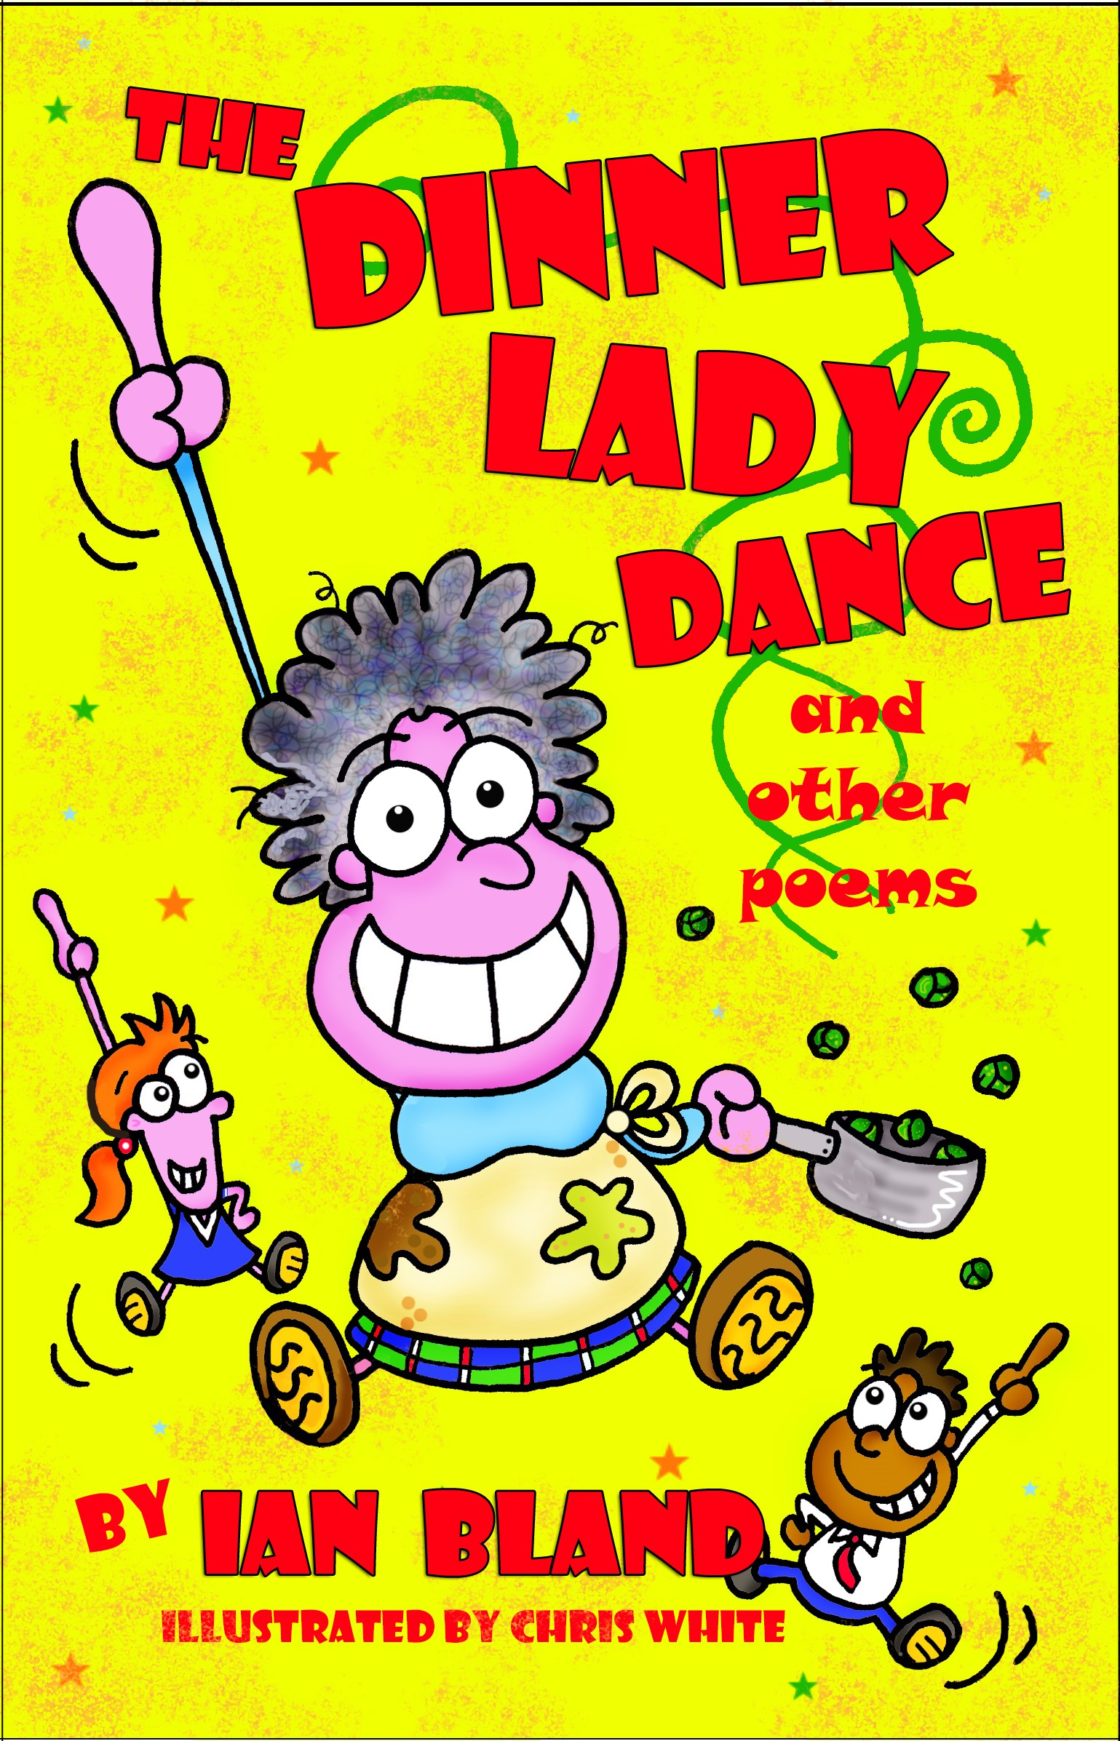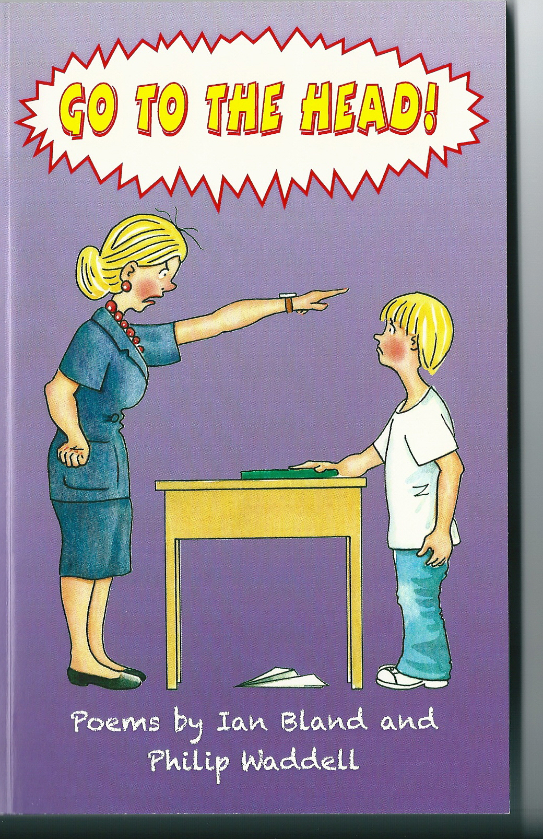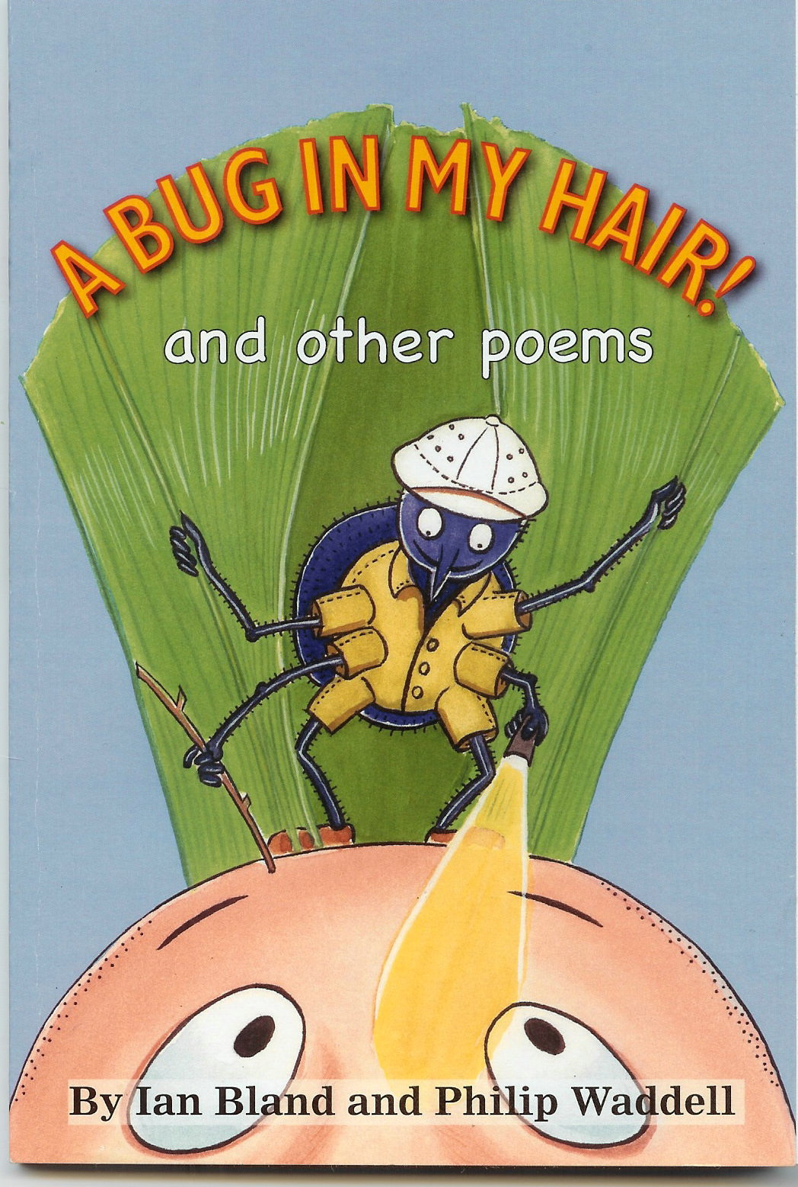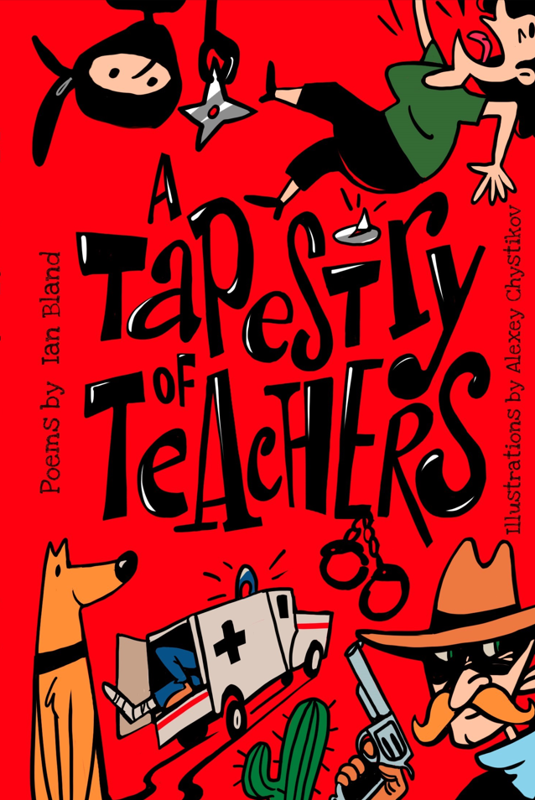

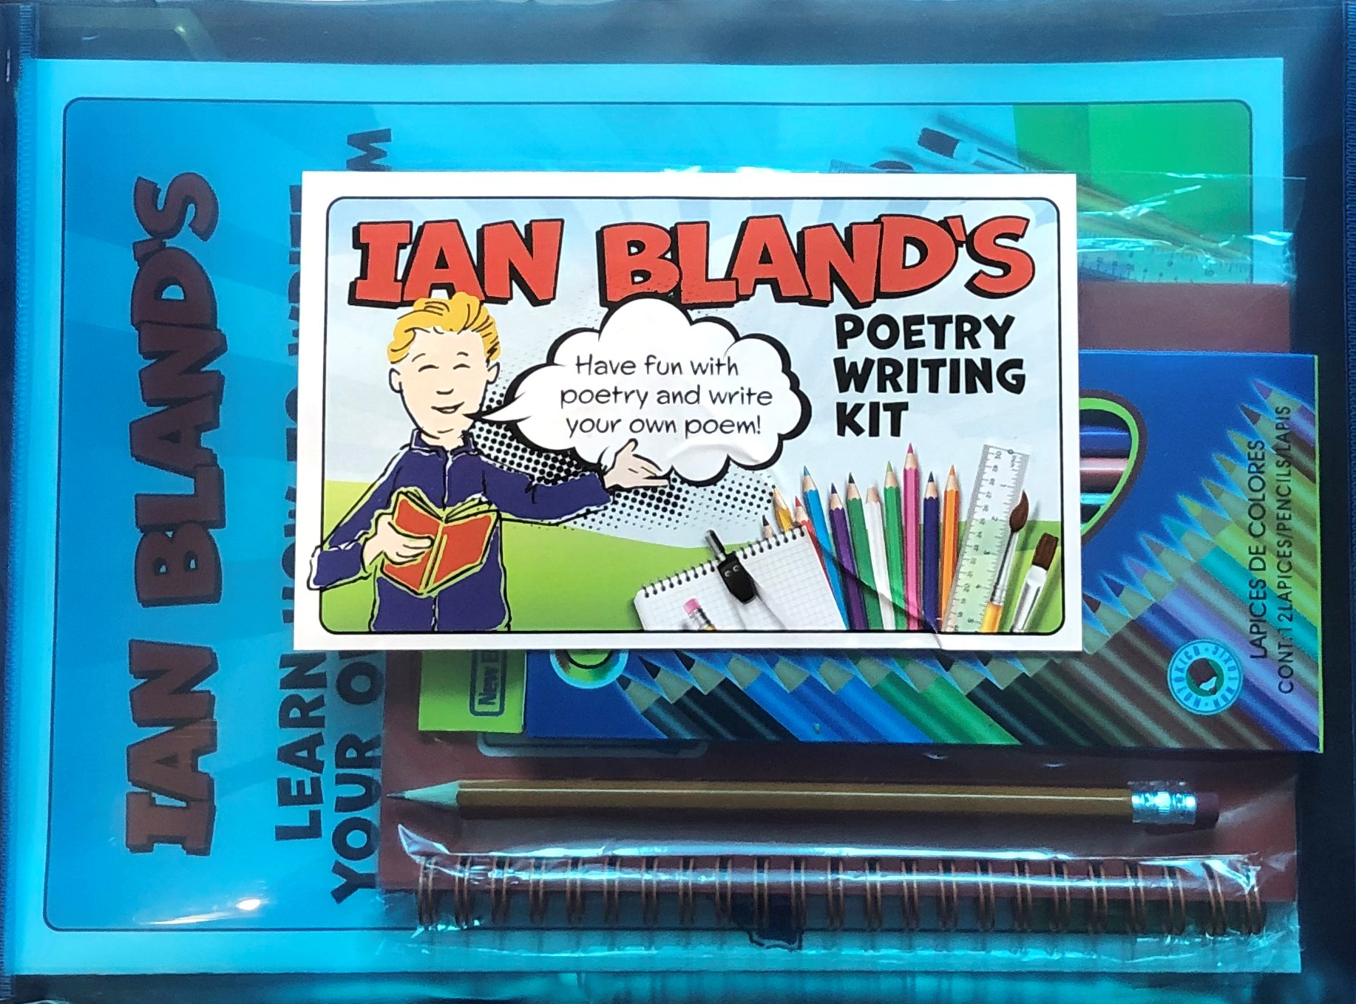
These books and the Poetry Writing Kit will be available from Ian at the end of the poetry day. The books are priced at £6.99, the Poetry Writing Kit is £7.99 (You can pay by cash or by contactless card.) Go To The Head!, The Dinner Lady Dance! and A Tapestry of Teachers are suitable for both KS1 and KS2. A Bug In My Hair is more aimed at KS1.

Ian Bland Poetry Book Order Form. Name___________

Book |  | Amount Required
The Dinner Lady Dance!
£6.99.
Go To The Head!
£6.99.
A Bug In My Hair!
£6.99.

A Tapestry of Teachers
£6.99.

Poetry Writing Kit
£7.99.

