

**Trade** – exchanging of goods

**Oba** – the Yoruba word meaning ‘King’

**Yoruba** – the name of the group of people who lived within the area of the holy city of Ife

**Ife** – the holy city nearby the Kingdom of Benin, ruled by the Yoruba people

**Edo** – The name of the group of people who lived within the ancient Kingdom of Benin

**Eweka** – the first Oba of the Kingdom of Benin. He came to power in AD 1180

**Benin City** – the modern city located in Nigeria. It used to be called Edo and Igodomigodo before that

**Ogiso** – the Edo word meaning ‘Kings of the Sky’

**IMPORTANT PEOPLE**

**Ogiso Igodo** – the first king or Ogiso of Benin

**Ogiso Owodo** – the last of the Igiso kings. He was exiled.

**Oba Eweke** – the first of a new dynasty of kings called the Obas Oba

**Oguole** – built the Benin City Wall **Oba Ewuare** – expanded the Kingdom greatly and set up the trading links with Portugal

**Oba Ovanramwen** – the last king of Benin, exiled by British troops after their invasion

Vocabulary:

Liverpool was a central port in the slave trade

The BritishEmpire is a term used to describe all the places around the world that were once ruled by Britain.

**I will be able to:**

* Evaluate the reliability and usefulness of different sources
* Form opinions based on a range of sources

**I will know:**

Benin is located in Nigeria

The Ancient Kingdom of Benin is NOT located in the modern country of Benin

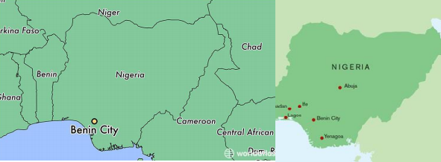 **THE ANCIENT KINGDOM OF BENIN: AD 900-1900**

* The Kingdom of Benin became a powerful empire in the 16th Century but was destroyed when it was invaded by British forces
* It began as a small group of villages that joined together to improve trade and security
* They produced quality goods to trade with foreigners
* The Obas were very powerful and were treated like gods
* In 1897, British troops invaded and gained control
* In the 1960s it became part of independent Nigeria.

What I already know:

What will I know by the end of this unit of work?

Waterloo Primary School – History Knowledge Organiser

Year: Year 6

Topic: Benin