

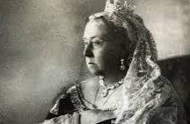

**I will be able to:**

Add the Victorian era to timeline beginning with the Stone Age

Select reliable sources to answer questions

**I will know:**

**Poor children often worked** in dangerous conditions.

**Queen Victoria’ s era coincides with the peak years of the British Empire.**

Queen Victoria believed that **education should be for all,** and by the end of her reign, going to school became compulsory for all children, rich or poor.

**Healthcare**saw huge improvements under the Victorians. Medical pioneers like [**Florence Nightingale**](https://www.natgeokids.com/uk/discover/history/general-history/florence-nightingale/) worked with the government to improve hospital cleanliness — which hadn’t been considered as important before!

The Victorian era saw huge developments in industry and transport

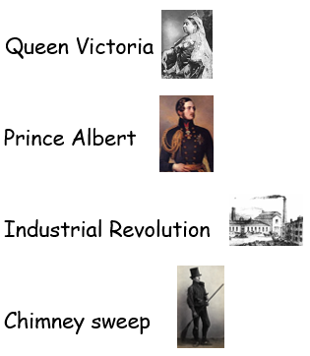 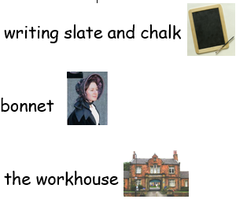

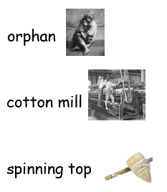 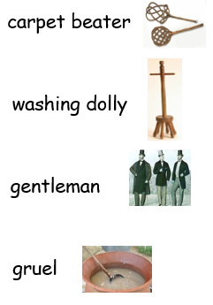

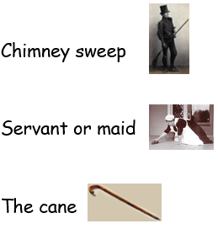 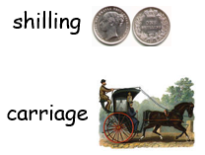

Vocabulary

**An Empire is a group of countries or states with one ruler**

**Use timelines with intervals of 10/100/1000 years, appreciating the length of different historical periods**

Topic: The Victorians

Year: 5

What should I already know?

What will I know by the end of this unit of work?

Waterloo Primary School – History Knowledge Organiser