

Titanic – a cruise ship that sank in 1912

Voyage – journey

Artefact – an object from the past

Maiden Voyage – the first journey a ship makes

Significant - important

New York – the city in America that the Titanic was sailing to

Southampton – the city in England the Titanic sailed from

Iceberg - A huge block of ice floating in the sea

Captain - Someone in charge of the ship

Unsinkable - Impossible to sink

Lifeboat - A small, emergency boat

Vocabulary

* How to order some events or objects on a timeline
* I can learn about the past in different ways

**I will be able to:**

* Sequence events in order
* Find answers to different questions

**I will know:**

* The Titanic was a cruise ship that sank on 15th April 1912 after hitting an iceberg
* The Titanic was described as “unsinkable.”
* The Titanic was on its first ever voyage from Southampton to New York
* On the Titanic there were 3 different classes: first, second and third class. First class was for rich people whilst third class was for poor people
* The Titanic’s Captain was called Edward John Smith
* Women and children were loaded onto the lifeboats first
* There were not enough lifeboats for everybody

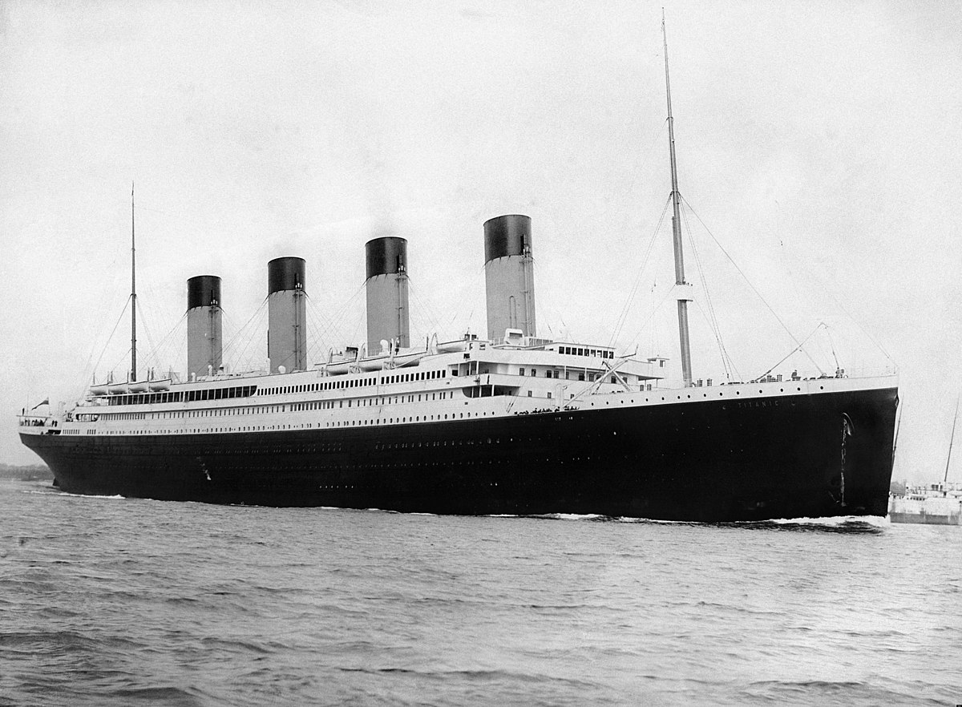

What should I already know?

What will I know by the end of this unit of work?

Strand: History

Waterloo Primary School – History Knowledge Organiser

Year:1

Topic: Titanic