

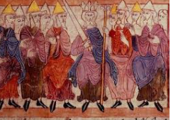

**I will be able to:**

* Use timelines to place and sequence events
* Conduct research in order to answer questions
* Discuss how rights differ from Anglo-Saxon Britain and present day

**I will know:**

* Anglo Saxons were a mix of tribes from Germany, Denmark and the Netherlands.
* They came to Britain in 410AD for a number of reasons
* Anglo Saxon Britain wasn’t ruled by one person
* They invaded in many different tribes and each took over a different part of Britain.

Anglo-Saxons – the Anglo-Saxon age in Britain was from around 410AD to 1066. They were a mix of tribes from Germany, Denmark and the Netherlands.

Scots– the Scots and Picts were attacking Britain from the North Sea. Britain invited the Anglo-Saxons to help defend the country.

Conflict – a struggle or clash between opposing forces, often resulting in battle.

Evidence – provides us with information about the past. Evidence can take many forms such as primary and secondary evidence.

Settlement – a city, town or village where people live and work.

Invasion – entering a country with an army.

Chronology - events or dates in the order they occurred.

Topic: Anglo-Saxons

What will I know by the end of this unit of work?

Vocabulary

Romans successfully invaded Britain in 43AD.   
The Romans settled in Britain and had a big influence on life here.

They remained in Britain until 410AD. The city of Rome was under attack and so Romans living in Britain were asked to leave, in order to defend their homeland.

Year: 4

What should I already know?

Waterloo Primary School – History Knowledge Organiser