

**Ancient -** belonging to the very distant past and no longer in existence.

**Archaeologist** - someone who studies the past by exploring old remains

**Common Era** - a method of numbering years which refers to the period of time that began after the birth of Jesus Christ

**Century** – 100 years

**Chronological** – order in which events occurred

**Emperor** – a sovereign ruler of an empire

**Invader -** a person or group that invades a country, region, or other place

**Source -** a place, person, or thing from which something originates or can be obtained

**Significance -** the quality of being worthy of attention; importance

**Irrigation –** movement of water to farmland

**Empire** – group of countries ruled by one monarch or ruler

**Trade** – buying/selling/exchanging.

Vocabulary

**I will be able to:**

* Use timelines to place events in order (intervals of 10/100/1000)
* Use words century/decade
* Use evidence to describe past
* Describe similarities and differences between people, events and objects
* Show changes on a timeline
* Look at 2 versions of the same event and identify differences
* Use pictures or objects to find information about the past

**I will know that:**

* The River Nile is in Egypt. Egypt is in Africa
* Ancient Egypt was before the year 0 on a timeline and is therefore BC
* They had pharaohs for leaders and Tutankhamen is the most famous
* Ancient Egyptians build pyramids
* The Ancient Egyptians build an empire

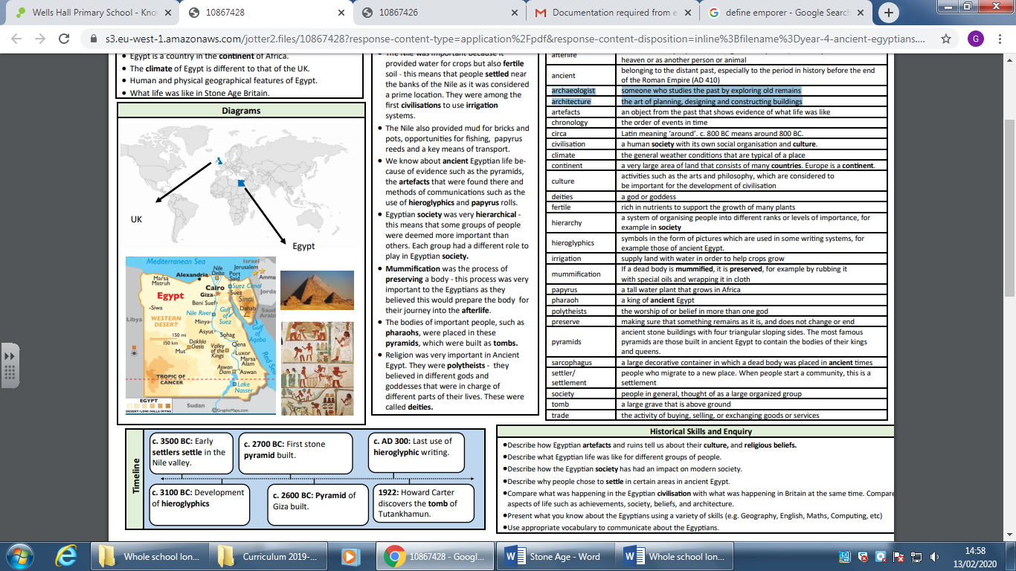

* Timelines can be divided into BC and AD
* How Ancient Egypt fits on a timeline

What will I know by the end of this unit of work?

Topic: Ancient Egypt

Year: 3

What should I already know?

Waterloo Primary School – History Knowledge Organiser