

**Equator –** a line notionally drawn on the earth equidistant from the poles, dividing the earth into northern and southern hemispheres and constituting the parallel of latitude 0° **Poles – Either of the points at which the Earth's axis of rotation intersects the Earth's surface - North Pole or South Pole  
Northern Hemisphere –** the half of the earth that is north of the equator **Southern Hemisphere –** the half of the earth that is south of the equator **Biome –** a large naturally occurring community of flora and fauna occupying a major habitat, e.g. forest or tundra **Vegetation Belt –** An area of the planet characterised by certain flora (plants) due to climatic conditions **Mountain –** a large natural elevation of the earth's surface rising abruptly from the surrounding level; a large steep hill  
**Alpine –** high mountain

**Avalanche -** a mass of snow, ice, and rocks falling rapidly down a mountainside **Altitude –** great height **Crevasse -** a deep open crack in a glacier **Drainage –** removal of water **Elevation –** raising something to a higher level **Erosion –** when material is worn away from the Earth’s surface

Vocabulary

which continents have significant hot or cold areas and how to relate these to the Poles and Equator.

Topic: Map skills, Equator, Poles, Hemispheres, Biomes, Vegetation Belts and Mountains

Year: 3

What should I already know?

I will be able to:

* Use maps and globes with increasing independence
* Use geographical vocabulary

I will know: 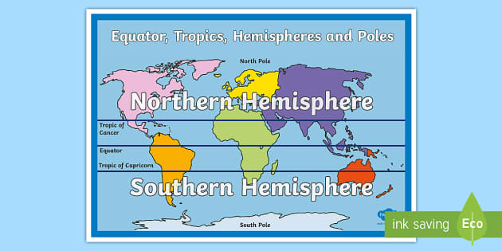

* The position of equator/poles/northern and southern hemisphere
* Key aspects of: **biomes**, **vegetation belts** and **mountains**.

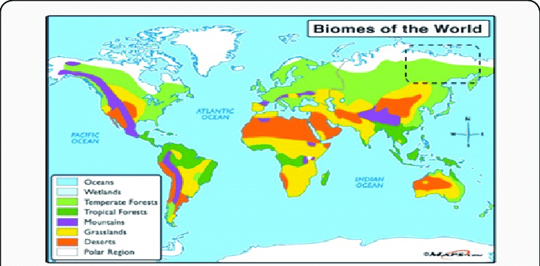

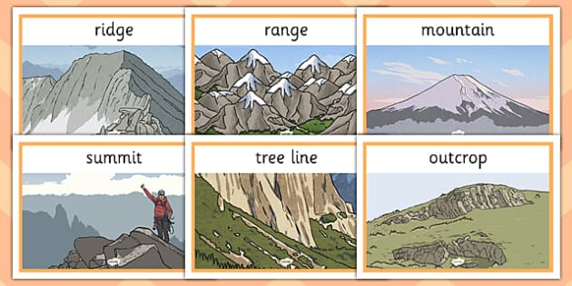

What will I know by the end of this unit of work?

Waterloo Primary School – Geography Knowledge Organiser