
- How to search for a picture.
- How to search for information.
- How to save files with support.
- That a range of technology can be used to find information/pictures.
- How to use technology to create, store, and retrieve data.
- How to make a range of simple digital assets such as presentations, movies, audio files and graphs.
- How to navigate websites.
- How to carry out simple searches.
Vocabulary
Simulation – the production of a computer model of something, especially for the purpose of study.
Sequence - a particular order in which related things follow each other.
Sprite – a computer graphic which may be moved on-screen and otherwise manipulated as a single entity.
Multimedia – integration of multiple forms of media. This includes text, graphics, audio, video, etc.
Control Block – a segment of disk or memory that contains a group of codes used for identification and control purposes.
Coding – programming a computer so that it understands what to do.
Complex – consisting of many different and connected parts.
Variable – an element, feature, or factor that is liable to vary or change.
Purpose - the reason for which something is done or created or for which something exist

I will know that:
- Simulations mimic a real life scenario.

I will know how to:
- Use a range of software and devices to create content for a purpose.
- Use more complex simulations and understand the effects of changing variables.
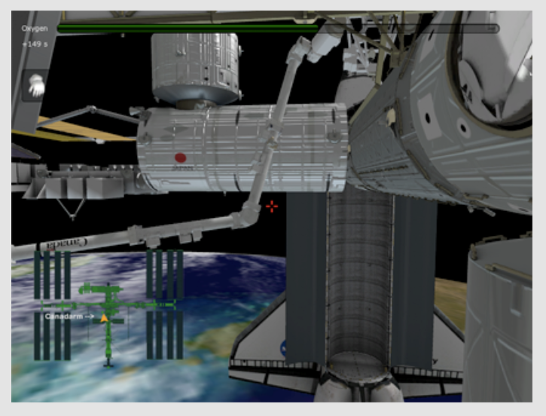
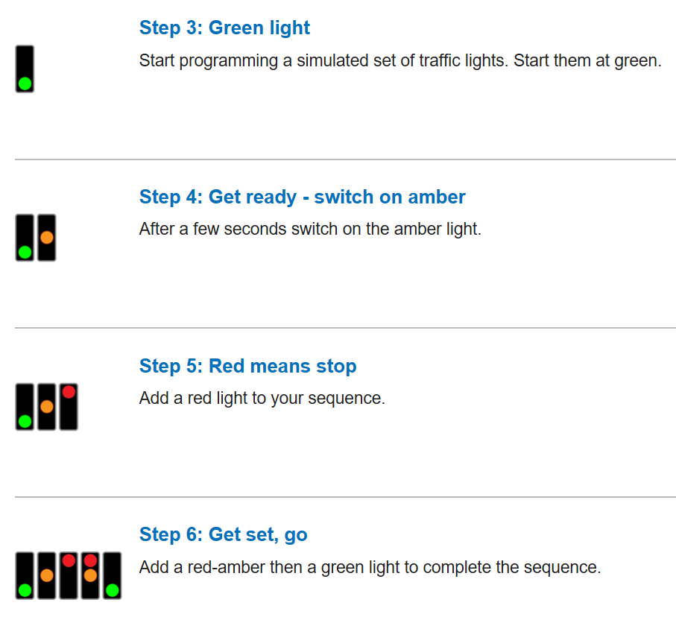
Topic: Information Technology
Year: 3
Waterloo Primary School – Computing Knowledge Organiser
What should I already know?
What will I know by the end of this unit of work?

