
- How to keep my information private.
- Why it is important to use technology safely.
- How to program a Bee-Bot to follow a route.
- How to recognise if a situation on the internet is not safe and how to report it.
- That I must follow the school’s acceptable use policy.
- That computers and the internet are used to communicate.

Vocabulary
URL - the address of a web page.
Untrusted - a party or system that may be malicious or unsafe.
Reliable - consistently good in quality or performance; able to be trusted.
Report - give a spoken or written account of something that one has observed, heard, done, or investigated.
Authenticate - have one's identity verified.
Verify - make sure or demonstrate that (something) is true, accurate, or justified.
Multimedia – integration of multiple forms of media. This includes text, graphics, audio, video, etc.
Network - a group or system of interconnected people or things.
Cyberbullying – the use of electronic communication to bully a person, typically by sending messages of an intimidating or threatening nature.
Blog - a regularly updated website or web page, typically one run by an individual or small group, that is written in an informal or conversational style.

I will know:
- That it is important to report any concerns when using the internet and how I can do so.
- What acceptable online behaviour is.

I will know how to:
- Use technology safely to keep information secure.
- Find out if a source is trustworthy.
- Create my own organisation for storing of files.

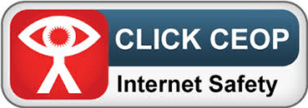
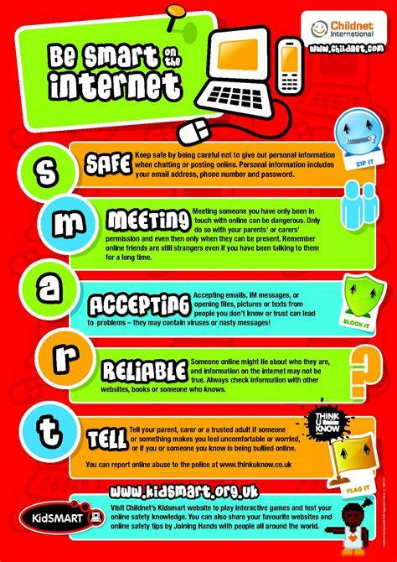
Topic: Digital Literacy
Year: 3
Waterloo Primary School – Computing Knowledge Organiser
What should I already know?
What will I know by the end of this unit of work?

