
- That an algorithm is steps to follow to achieve a task.
- That algorithms can be implemented as programs on devices.
- What debugging is.
- That programs work by following a precise set of instructions.
- How to create simple programs and algorithms.
- How to predict outcomes in the algorithms I create.

Vocabulary
Algorithm - a process or set of rules to be followed in calculations or other problem-solving operations, especially by a computer.
Sprite – a computer graphic which may be moved on-screen and otherwise manipulated as a single entity.
Control Block – a segment of disk or memory that contains a group of codes used for identification and control purposes.
Coding – programming a computer so that it understands what to do.
Command - an instruction or signal causing a computer to perform one of its basic functions.
Decomposition – breaking a problem down into smaller parts to make it easier to tackle.
Variable – an element, feature, or factor that is liable to vary or change.
Debug - identify and remove errors from (computer hardware or software).
.

I will know that:
- Computers can be part of a network, and how these networks can be used.

I will know how to:
- Plan and write algorithms.

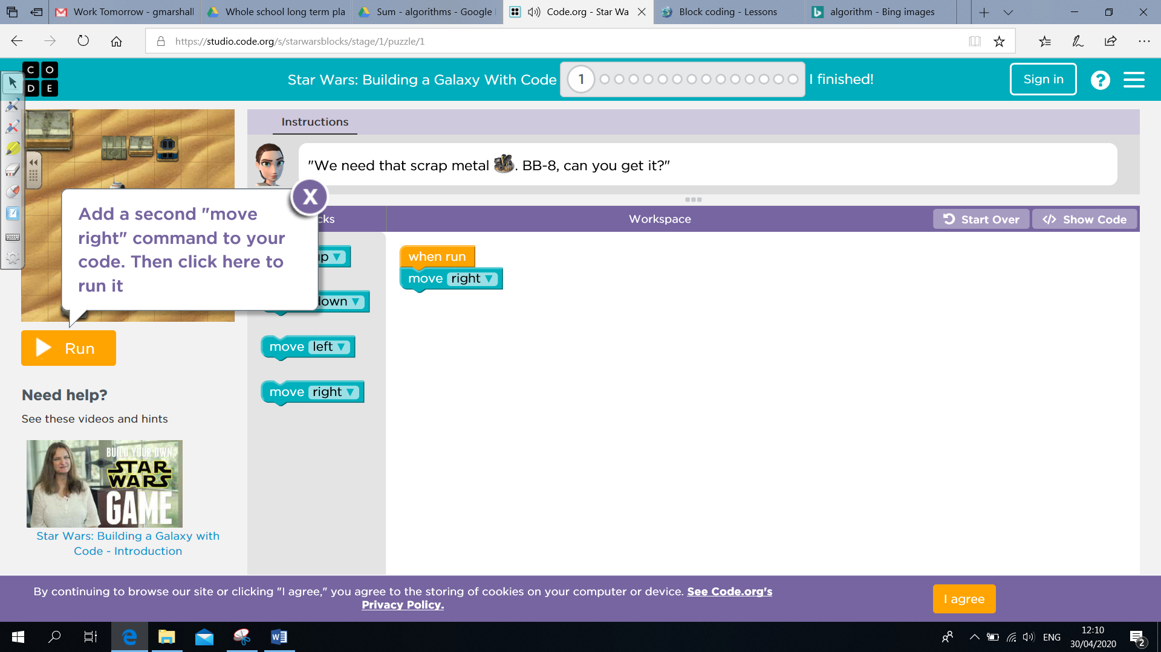

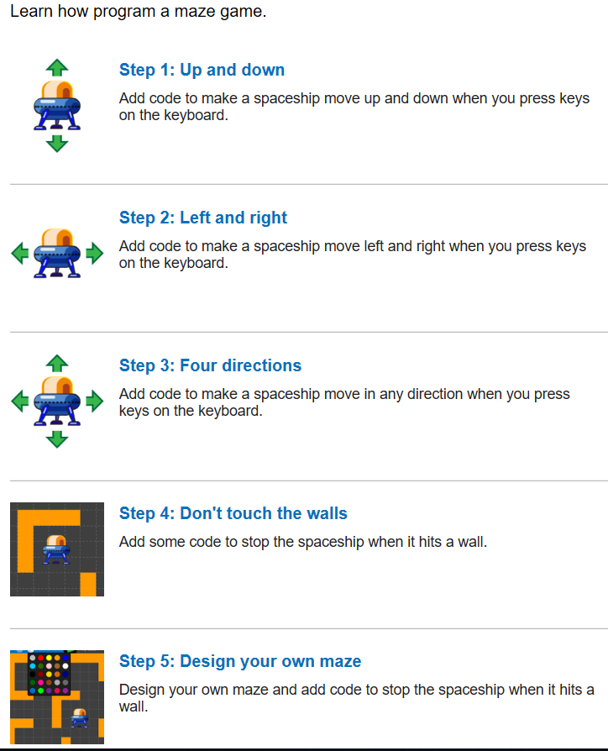
Topic: Computer Science
Year: 3
Waterloo Primary School – Computing Knowledge Organiser
What should I already know?
What will I know by the end of this unit of work?

