
- How to use the internet safely.
- Search engines help us to gather information.

Vocabulary
Boolean operators – they connect your search words together to either narrow or broaden your search
Search engines – programs that are designed to search the internet for us.
Key words – selecting language specific to the topic you are researching
Computer – an electronic device which receives data and performs operations.
Listed links –the results are listed in order with the most popular being at the top.
Algorithms – a process a search engine uses to help find what you are looking for.

I will be able to:
- Understand the importance of passwords
- Understand the need to keep personal information private
- Recognise the importance of being a good digital citizen.
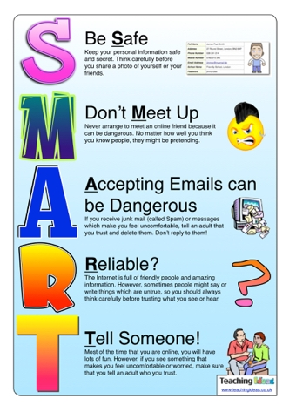
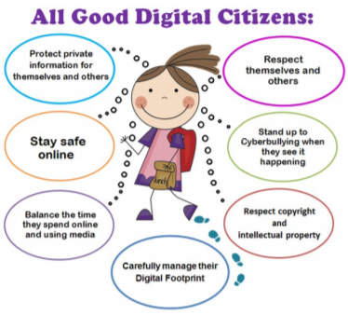

Topic: Digital Literacy
Year: 4
Waterloo Primary School – Computing Knowledge Organiser
What should I already know?
What will I know by the end of this unit of work?

