

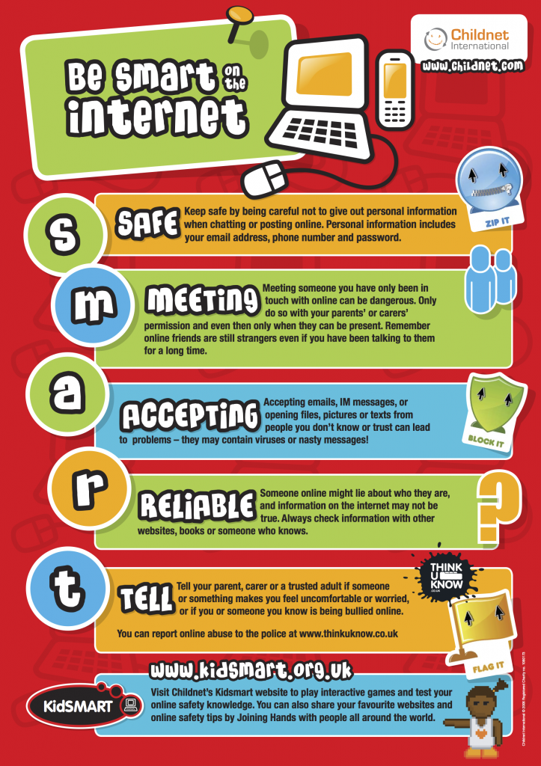

- Know how to recognise if a situation on the internet is safe.
- Know who to speak to if they have any concerns about their online safety.
- Know what information should be kept private.
- Know how to follow the school E-Safety rules.
- Begin to assess if something is trustworthy.
- Know how computers and a range of technology are used to communicate.
Browser – a computer program used to navigate the World Wide Web.
Computer networks – connected devices that make it possible to transfer data using an agreed method (protocol).
Input- a method of computers receiving data (keyboard, mouse etc).
Output – the information produced by a computer system, typically on screen, through speakers or on a printer. Also an action performed by the computer e.g. switching on a light, moving a turtle or sprite across the screen.
Software- computer programs and applications (apps).
WWW – World Wide Web.
Internet Safety- trying to stay safe on the internet and is the knowledge of keeping the user’s personal safe and security risks to private information.
Fictitious/Fake– something that is not real.

Vocabulary
General skills – turning on a computer, logging on and accessing some programs.
Some basic processing skills on Word or PowerPoint.
Understanding and identifying different technology.
Simple E-Safety rules and knowledge.
Simple coding.
What should I already know?
What will I know by the end of this unit of work?
Year: 2
Topic: Digital Literacy
Waterloo Primary School – Computing Knowledge Organiser

