


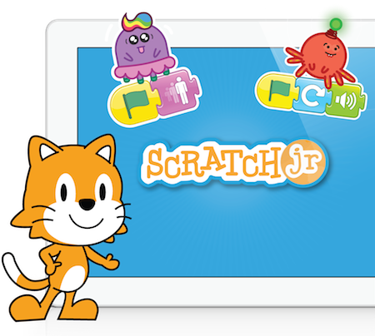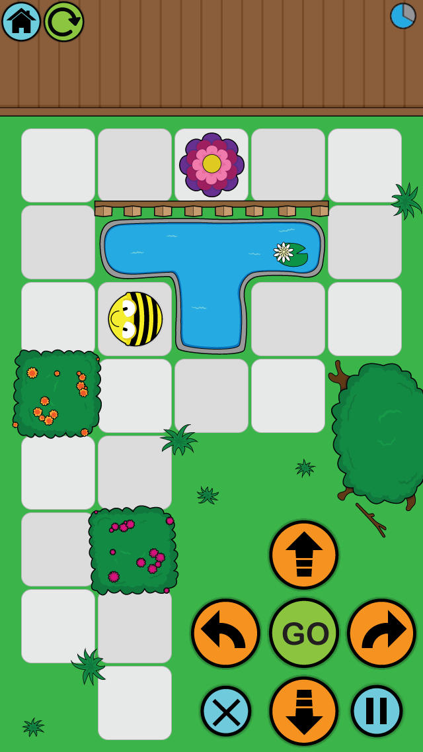

- Know how to create simple algorithms on the computer and other devices such as iPads (apps).
- Know how to find errors and debug simple algorithms.
- Know what the words algorithm, program and debug mean.
- Create algorithms and predict the outcome.
- Implement skills across a range of programs.

Input- a method of computers receiving data (keyboard, mouse etc).
Output – the information produced by a computer system, typically on screen, through speakers or on a printer. Also an action performed by the computer e.g. switching on a light, moving a turtle or sprite across the screen.
Software- computer programs and applications (apps).
Repeat/loop- instructions that can be repeated until a condition is met.
Debug – finding and correcting areas.
Programs– a sequence of instructions written to perform a specified task on a computer.
Algorithm – clear steps or instructions to follow to achieve a task.
Characters/avatars/sprite- an object that can be controlled by programming. Scratch projects are made up of objects called Sprites.

Vocabulary
General skills – turning on a computer, logging on and accessing some programs.
Some basic processing skills on Word or PowerPoint.
Understanding and identifying different technology.
Simple E-Safety rules and knowledge.
Simple coding.
What should I already know?
What will I know by the end of this unit of work?
Year: 2
Topic: Computer Science
Waterloo Primary School – Computing Knowledge Organiser

