
- How to gather information from the internet?
- That their work can be presented in different ways
- That the internet should be used safely.
Vocabulary
Multimedia – the use a variety of artistic or communicative media.
Computer – an electronic device which receives data and performs operations.
Text – the written word.
Font – the particular size and style of text
Select – highlighting chosen text or pictures.
Paste – places selected text or picture in desired location.
Resize – manipulate text or image to desired size.
Boolean Operators – they connect your search words together to either narrow or broaden your search.
Search Engines – programs that are designed to search the internet for us.
Key Words – selecting language specific to the topic you are researching.
Computer – an electronic device which receives data and performs operations.
Listed Links –the results are listed in order with the most popular being at the top.
Algorithms – a process a search engine uses to help find what you are looking for.

I will be able to:
- Select and use a variety of software.
- Select, use and combine a variety of software.
- Gather relevant information from the internet.
- Further develop research skills to present findings.
- Understand how Boolean operators can refine a search.
- To select suitable photos from their project and add them to their presentation
Pupils will be able to use a combination of research, their own records of their projects together with a Microsoft presentation to create a final piece.
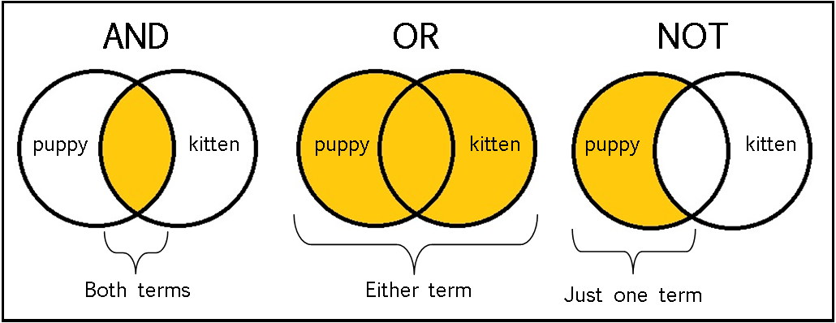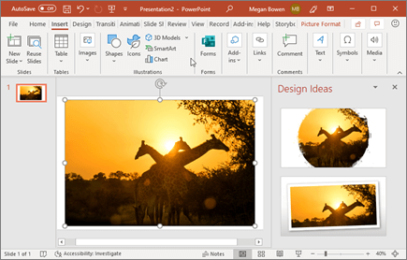
Topic: Information Technology
Year: 4
Waterloo Primary School – Computing Knowledge Organiser
What should I already know?
What will I know by the end of this unit of work?

